Matt Maloney  
IST 659 Project deliverable  
03/23/2019

Contents

Part1: Design 2

Project Narrative 2

Data dictionary 2

Data Questions 5

Entity Relationship Diagram 5

Logical Model Diagram 6

Part 2: 7

Physical Database Design: 7

Data Creation: 12

Data Manipulation: 15

Answering Data Questions: 17

Implementation: 20

Reflection: 23

SQL script: 24

Figure 1: Data dictionary 4

Figure 2: Conceptual model 5

Figure 3: Normalized logical model 6

Figure 4: Data insertion into "School" table 12

Figure 5: Data insertion into "Student" table 13

Figure 6: Data insertion into "Staff" table 14

Figure 7: Data insertion into "Event" table 15

Figure 8: View – MattTrips 15

Figure 9: Procedure – SelectTrips 16

Figure 10: View - Cornell Approvals 16

Figure 11: Procedure – SchoolApproval 16

Figure 12: View – CornellMaterials 17

Figure 13: Procedure – EventMaterials 17

Figure 14: Code for Count of Students by School 17

Figure 15: Count of Students by School 18

Figure 16: Code for Sum of EventMaterialQty by School 18

Figure 17: EventMaterialQty by School 19

Figure 18: Code for staff members listed as 'Emergency 19

Figure 19: Emergency contacts 20

Figure 20: Code for StudentBill procedure 20

Figure 21: StudentBill procedure results for AppID 46981 20

Figure 22: All tables of Syracuse Abroad database in Access with the Event table open 21

Figure 23: Relationships as portrayed within Access 21

Figure 24: A report detailing materials used at events 22

# Part1: Design

## Project Narrative

Syracuse University occupies a unique space in the international education sphere. There are typically three types of study abroad arrangements: direct exchanges with universities abroad, third party provider programs (operated by institutions that are neither American universities nor universities abroad), and programs operated by American universities abroad. While nearly all American institutions offer study abroad programming through a patchwork of these agreements, Syracuse is among only a handful of schools that operate their own study abroad programs throughout the world.

In addition to providing study abroad opportunities for Syracuse students, Syracuse programs abroad are open to “visiting students,” or students that attend another American university but spend a semester or summer on a Syracuse program overseas. At Syracuse Abroad, one department within the unit dedicates itself to cultivating relationships with domestic partner institutions and recruiting their students to apply to Syracuse Abroad programs. This department is called “Institutional Relations” and is made up of three full-time staff members.

At this time, the unit as a whole utilizes a number of information management systems to conduct the daily business of recruiting, retaining, preparing, billing, and supporting students throughout the different phases of the study abroad process. These systems include: Terra Dotta Systems, Oracle PeopleSoft, Frevvo, and Constant Contact, among others. Despite the presence of these various tools, the Institutional Relations team still does not have a system that caters to its needs.

This team is tasked with liaising with partner school staff, messaging prospects, attending study abroad fairs at domestic institutions, and shepherding various stakeholders on annual site visits to our Centers around the world. These responsibilities present the need for efficient and easy access to a wide variety of data points.

## Data dictionary

|  |  |  |
| --- | --- | --- |
| **Entity** | **Attribute** | **Properties** |
| School | School ID | Required. Unique identifier for each school. |
|  | School Name | Required. |
|  | School Name (Colloquial) | Required. Name will be merged into letters, marketing materials, and other phones of communications. |
|  | Address | Required. Composite of Street Address, City, State, and Postal Code |
| Student | Student ID | Required. Unique identifier for each student. |
|  | Student Name | Required. Composite of First Name and Last Name |
| Staff | Staff ID | Required. Unique identifier for each staff member. |
|  | Staff Name | Required. Composite of First Name and Last Name. |
|  | Title | Required. Current title at current institution. |
|  | Phone | Required. |
|  | Email | Required. |
|  | Position | Internal designation. Allows users to assign roles within a specific partner instituion. Ex: emergency contact, Italy programs adviser, etc. |
| Event | Event ID | Required. Unique identifier for each event. |
|  | Date | Required. |
|  | Time |  |
|  | Location | Required. Depending on the type of event, the location might not be as specific as an address. |
|  | Address | Composite of Street Address, City, State, and Postal Code |
| Material | Material ID | Required. Unique identifier of material. |
|  | Type | Required. Assigns a specific material to a class. Example: viewbook, inquiry card, keychain, pen, etc. |
| Program | Program ID | Required. Unique identifier for each program. |
|  | Capacity | Required. Defines the upper limit of students that can enroll in a given program. |
|  | Housing Type | Required. Defines housing arrangment for a given program: homestay, apartment, dormitory, etc. |
|  | Region | Required. Gives geographic information about programs' whose Program Name is not intuitive. |
|  | Program Name | Required. |
|  | Program Type | Required. Classifies program as Semester, Summer, or Short-Term. |
| Center | Center ID | Required. Unique identifier for each Center. |
|  | Location | Required. Nominal location of the Center. This is to account for a Center that might be located in a suburb of major city, but referred to as a part of the bigger municipality. |
|  | Address | Required. Composite of Street Address, City, State, Postal Code, Country. |
| Agreement | Agreement ID | Required. Unique identifier for each agreement. |
|  | Billed By | Required. Campus unit that process bill. |
|  | Billed To | Required. Party that receives and pays bill. |
|  | Tuition Differential | Required. Amount of tuition differential grant applied to bill. |
|  | Agreement Type | Required. An internal designation that is assigned to different types of billing arrangements. |
|  | Custom Award | Additional tuition differential dollars that might be applied to certain Schools. |
| Course | Course ID | Required. Unique identifier for each course. |
|  | Course Number | Required. Catalog number for each course. |
|  | Course Name | Required. |
|  | Fall | Required. Is the course offered in the fall semester? |
|  | Spring | Required. Is the course offered in the spring semester? |
|  | Summer | Required. Is the course offered in the summer term? |
|  |  |  |

Figure : Data dictionary

## Data Questions

Syracuse Abroad plans to use this database to answer the following questions:

1. Which American institutions send the most students on Syracuse programs?

2. Which events require the most material resources?

3. Which staff members at partner schools can be contacted for various concerns (academic, disciplinary, emergency)?

4. How should a given student be billed?

These are but a few of the many questions that an effective database will be required to answer.

## Entity Relationship Diagram

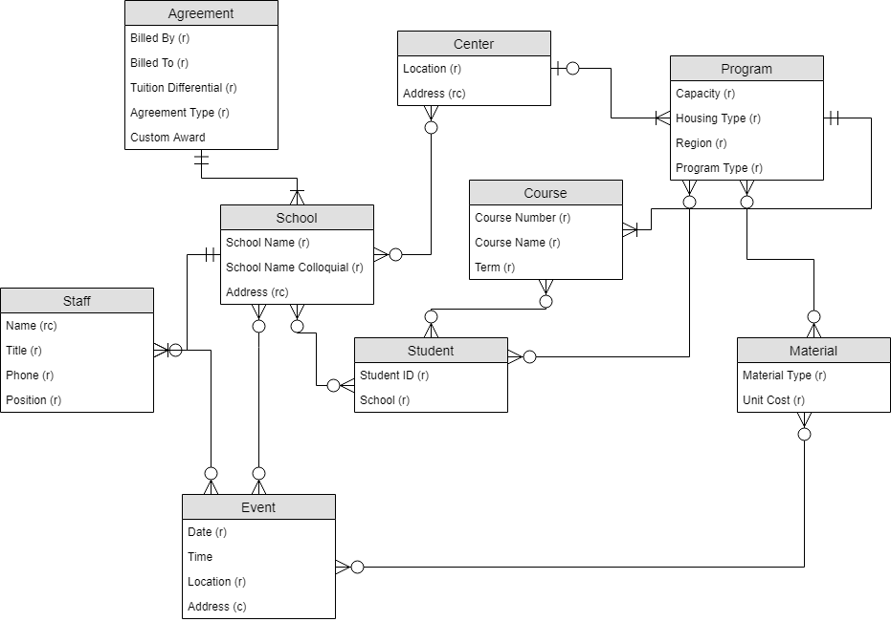

Figure 2: Conceptual model

## Logical Model Diagram

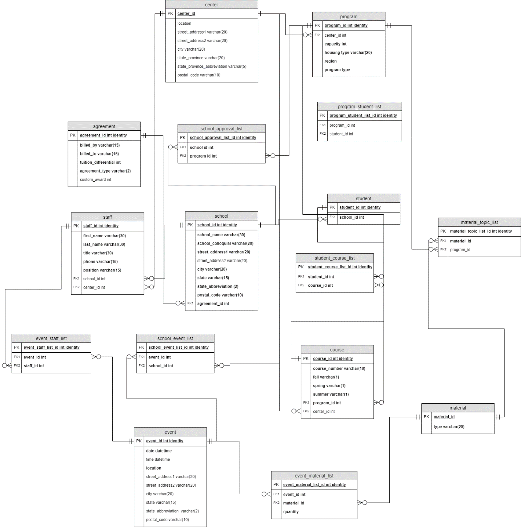

Figure : Normalized logical model

# Part 2:

## Physical Database Design:

In this section, you can see the various tables that I created in SQL:

-- Creating the School table

CREATE TABLE School (

-- Columns for School table

SchoolID int identity,

SchoolName varchar(50) not null,

SchoolNameColloquial varchar(30) not null,

SchoolStreet varchar(30) not null,

SchoolStreet2 varchar(30),

SchoolCity varchar(30) not null,

SchoolState varchar(2) not null,

SchoolZip varchar(10) not null,

-- Constraints on the School table

CONSTRAINT PK_School PRIMARY KEY (SchoolID),

CONSTRAINT U1_School UNIQUE (SchoolName)

)

-- Creating Center table

CREATE TABLE Center (

-- Columns for Center table

CenterID int identity,

CenterLocation varchar(40) not null,

CenterStreet varchar(30) not null,

CenterStreet2 varchar(30),

CenterCity varchar(30) not null,

CenterStateProvince varchar(15) not null,

CenterPostal varchar(10) not null,

CenterCountry varchar(30) not null,

-- Constraints on the School table

CONSTRAINT PK_Center PRIMARY KEY (CenterID),

CONSTRAINT U1_CenterLocation UNIQUE (CenterLocation),

)

-- Creating Agreement table

CREATE TABLE Agreement (

-- Columns for Agreement table

AgreementID int identity,

BilledBy varchar(30) not null,

BilledTo varchar(30) not null,

TuitionDifferential int not null,

AgreementType varchar(2) not null,

CustomAward int,

-- Constraints on the School table

CONSTRAINT PK_Agreement PRIMARY KEY (AgreementID)

)

-- Creating Material table

CREATE TABLE Material (

-- Columns

MaterialID int identity,

MaterialType varchar(20) not null,

-- Constraints

CONSTRAINT PK_Material PRIMARY KEY (MaterialID)

)

-- Creating Event table

CREATE TABLE Event (

-- Columns

EventID int identity,

EventDate datetime not null,

EventTime datetime,

EventLocation varchar(50) not null,

EventStreet varchar(30),

EventStreet2 varchar(30),

EventCity varchar(30),

EventStateProvince varchar(15),

EventPostal varchar(10),

EventCountry varchar(30),

-- Constraints

CONSTRAINT PK_Event PRIMARY KEY (EventID),

)

ALTER TABLE Event ADD EventName varchar(50)

-- Creating Program table

CREATE TABLE Program (

-- Columns

ProgramID int identity,

CenterID int,

ProgramCapacity int not null,

ProgramHousing varchar(20) not null,

ProgramRegion varchar(20) not null,

ProgramType varchar(20) not null,

-- constraints

CONSTRAINT PK_Program PRIMARY KEY (ProgramID),

CONSTRAINT FK_Program FOREIGN KEY (CenterID) REFERENCES Center(CenterID)

)

ALTER TABLE Program ADD ProgramName varchar(100)

-- Creating Student table

CREATE TABLE Student (

-- Columns

StudentID int identity,

SchoolID int not null

-- constraints

CONSTRAINT PK_Student PRIMARY KEY (StudentID),

CONSTRAINT FK_Student FOREIGN KEY (SchoolID) REFERENCES School(SchoolID)

)

ALTER TABLE Student ADD SystemAppID int

-- Creating Course table

CREATE TABLE Course (

-- Columns

CourseID int identity,

CourseNumber varchar(10) not null,

CourseFall varchar(1) not null,

CourseSpring varchar(1) not null,

CourseSummer varchar(1) not null,

ProgramID int not null,

CenterID int,

-- constraints

CONSTRAINT PK_Course PRIMARY KEY (CourseID),

CONSTRAINT FK_Course FOREIGN KEY (ProgramID) REFERENCES Program(ProgramID),

CONSTRAINT FK2_Course FOREIGN KEY (CenterID) REFERENCES Center(CenterID)

)

-- Updating School table

-- Add Column for Agreement

ALTER TABLE School

ADD AgreementID int

-- Make Agreement foreign key

ALTER TABLE School

ADD CONSTRAINT FK_School FOREIGN KEY (AgreementID) REFERENCES Agreement(AgreementID)

-- Creating ProgramStudentList

CREATE TABLE ProgramStudentList (

ProgramStudentListID int identity,

ProgramID int,

StudentID int,

CONSTRAINT PK_ProgramStudentList PRIMARY KEY (ProgramStudentListID),

CONSTRAINT FK_ProgramStudentList FOREIGN KEY (ProgramID) REFERENCES Program(ProgramID),

CONSTRAINT FK2_ProgramStudentList FOREIGN KEY (StudentID) REFERENCES Student(StudentID)

)

-- Creating SchoolApprovalList

CREATE TABLE SchoolApprovalList (

SchoolApprovalListID int identity,

SchoolID int,

ProgramID int,

CONSTRAINT PK_SchoolApprovalList PRIMARY KEY (SchoolApprovalListID),

CONSTRAINT FK_SchoolApprovalList FOREIGN KEY (SchoolID) REFERENCES School(SchoolID),

CONSTRAINT FK2_SchoolApprovalList FOREIGN KEY (ProgramID) REFERENCES Program(ProgramID)

)

-- adding not null

ALTER TABLE SchoolApprovalList

ALTER COLUMN SchoolID int not null

ALTER TABLE SchoolApprovalList

ALTER COLUMN ProgramID int not null

-- Creating MaterialTopicList

CREATE TABLE MaterialTopicList (

MaterialTopicListID int identity,

MaterialID int,

ProgramID int,

CONSTRAINT PK_MaterialTopicList PRIMARY KEY (MaterialTopicListID),

CONSTRAINT FK_MaterialTopicList FOREIGN KEY (MaterialID) REFERENCES Material(MaterialID),

CONSTRAINT FK2_MaterialTopicList FOREIGN KEY (ProgramID) REFERENCES Program(ProgramID)

)

-- Adding not null

ALTER TABLE MaterialTopicList

ALTER COLUMN MaterialID int not null

-- Creating StudentCourseList

CREATE TABLE StudentCourseList (

StudentCourseListID int identity,

StudentID int,

CourseID int,

CONSTRAINT PK_StudentCourseList PRIMARY KEY (StudentCourseListID),

CONSTRAINT FK_StudentCourseList FOREIGN KEY (StudentID) REFERENCES Student(StudentID),

)

-- Update to include second FK

ALTER TABLE StudentCourseList

ADD CONSTRAINT FK2_StudentCourseList FOREIGN KEY (CourseID) REFERENCES Course(CourseID)

-- Add not null

ALTER TABLE StudentCourseList

ALTER COLUMN StudentID int not null

ALTER TABLE StudentCourseList

ALTER COLUMN CourseID int not null

-- Creating SchoolEventList table

CREATE TABLE SchoolEventList (

SchoolEventListID int identity,

EventID int not null,

SchoolID int not null,

CONSTRAINT PK_SchoolEventList PRIMARY KEY (SchoolEventListID),

CONSTRAINT FK_SchoolEventList FOREIGN KEY (SchoolID) REFERENCES School(SchoolID),

CONSTRAINT FK2_SchoolEventList FOREIGN KEY (EventID) REFERENCES Event(EventID)

)

-- Creating EventMaterialList

CREATE TABLE EventMaterialList (

EventMaterialListID int identity,

EventID int not null,

MaterialID int not null,

EventMaterialQty int not null,

CONSTRAINT PK_EventMaterialList PRIMARY KEY (EventMaterialListID),

CONSTRAINT FK_EventMaterialList FOREIGN KEY (EventID) REFERENCES Event(EventID),

CONSTRAINT FK2_EventMaterialList FOREIGN KEY (MaterialID) REFERENCES Material(MaterialID)

)

-- Creating Staff

CREATE TABLE Staff (

StaffID int identity,

FirstName varchar(20) not null,

LastName varchar(30) not null,

StaffTitle varchar(30) not null,

StaffPhone varchar(15) not null,

StaffEmail varchar(30) not null,

StaffRole varchar(30) not null,

SchoolID int,

CenterID int,

CONSTRAINT PK_Staff PRIMARY KEY (StaffID),

CONSTRAINT FK_Staff FOREIGN KEY (SchoolID) REFERENCES School(SchoolID),

CONSTRAINT FK2_Staff FOREIGN KEY (CenterID) REFERENCES Center(CenterID),

CONSTRAINT U_Staff UNIQUE (StaffEmail)

)

-- Creating EventStaffList

CREATE TABLE EventStaffList (

EventStaffListID int identity,

EventID int,

StaffID int,

CONSTRAINT PK_EventStaffList PRIMARY KEY (EventStaffListID),

CONSTRAINT FK_EventStaffList FOREIGN KEY (EventID) REFERENCES Event(EventID),

CONSTRAINT FK2_EventStaffList FOREIGN KEY (StaffID) REFERENCES Staff(StaffID)

)

-- Application table is missing

DROP TABLE ProgramApp

CREATE TABLE ProgramApp (

ProgramAppID int identity,

StudentID int,

ProgramID int,

AppSemester varchar(10),

AppYear datetime,

CONSTRAINT PK_ProgramApp PRIMARY KEY (ProgramAppID),

CONSTRAINT FK_ProgramApp FOREIGN KEY (ProgramID) REFERENCES Program(ProgramID),

CONSTRAINT FK2_ProgramApp FOREIGN KEY (StudentID) REFERENCES Student(StudentID)

)

## Data Creation:

Because there are almost 2,000 lines of code in the data insertion section, I will upload the full SQL script in a separate file. For reference, here are a few screenshots of the data that I inserted into the various tables.

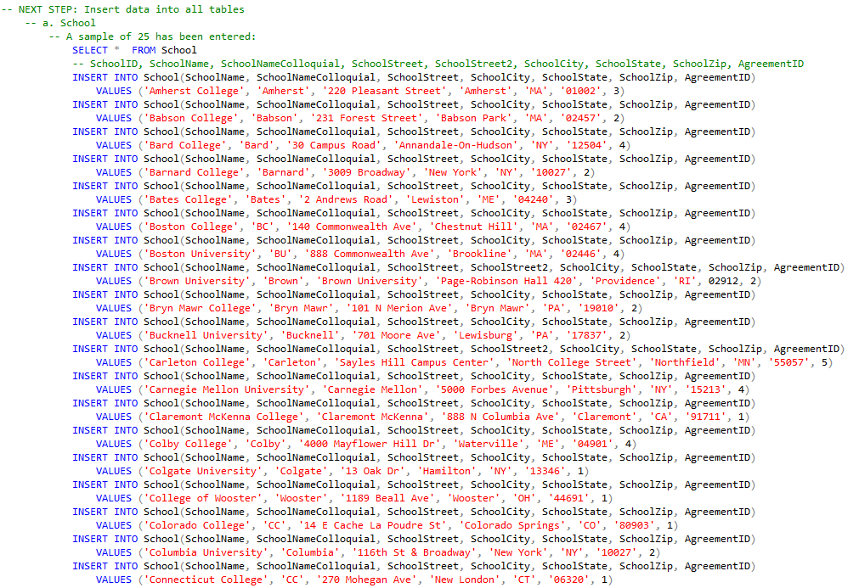

Figure : Data insertion into "School" table

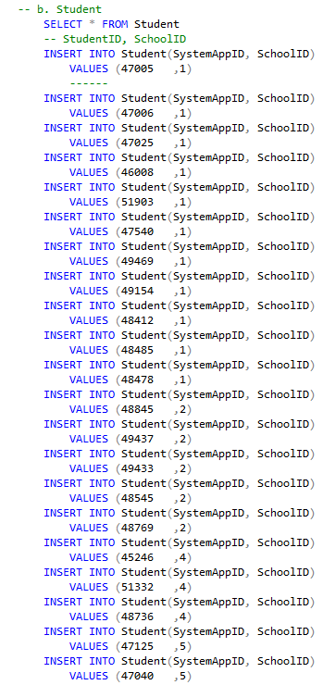

Figure : Data insertion into "Student" table

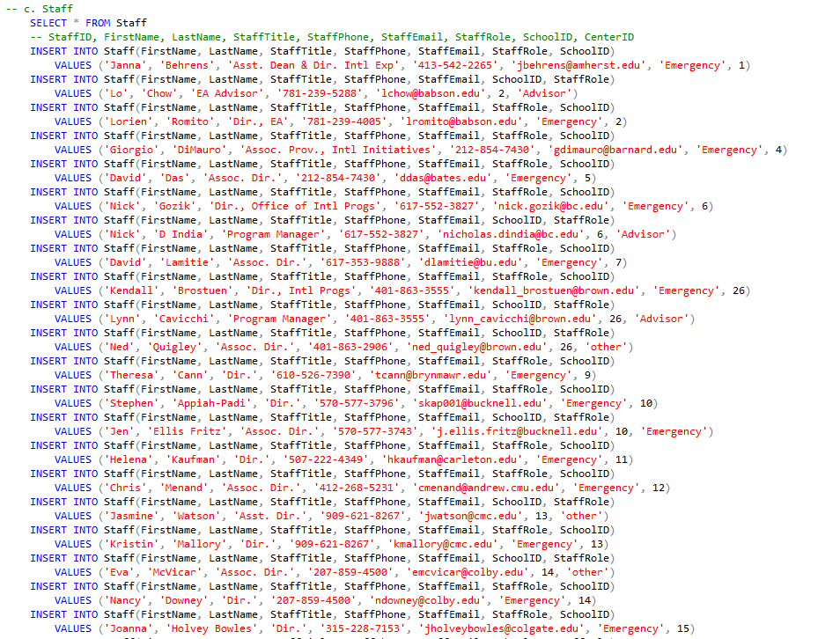

Figure : Data insertion into "Staff" table

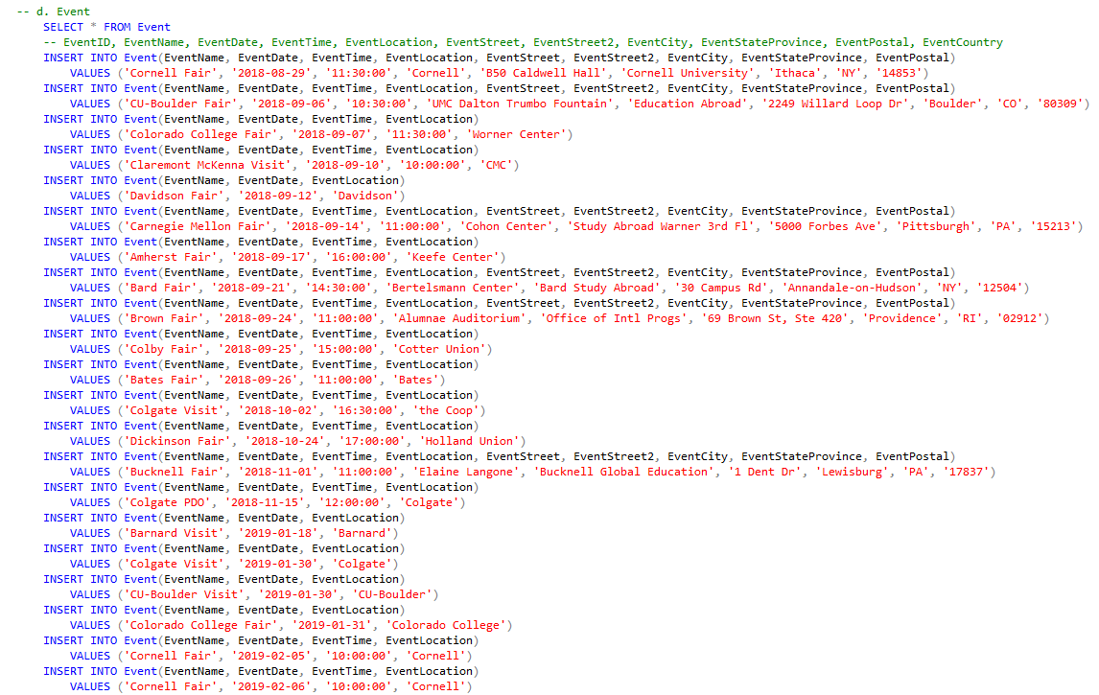

Figure : Data insertion into "Event" table

In total, 16 tables were populated with data. This was a painstaking process, but valuable in understanding how the data fit together!

## Data Manipulation:

In order to assist in retrieving various columns from the 16 tables, I have created a few views. Most of these views were later upgraded to procedures so that a user could find information specific to his/her situation with ease.

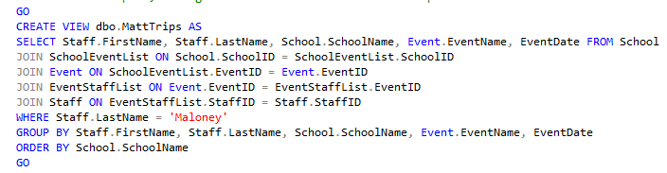

Figure : View – MattTrips

One example of this is the View labeled “MattTrips.” While this would be helpful for me as I reflect on the visits I have made to various partner schools, it might not be as helpful for my colleagues. In order to better assist them, this view spawned a more useful procedure.

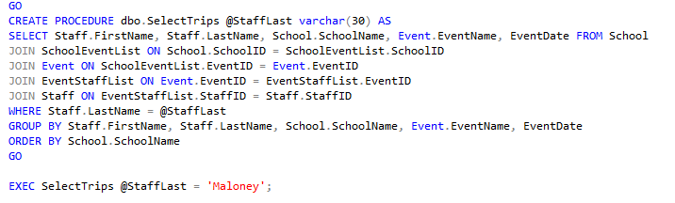

Figure : Procedure – SelectTrips

By using the “StaffLast” column of the Staff table as a procedural variable, other members of my team will be able to search a last to discover which visits have been made by any one staffer.

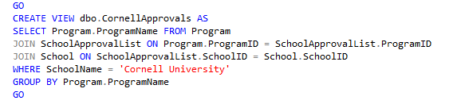

Figure : View - Cornell Approvals

Another example of this was the above view to see which of our programs are approved by Cornell, one of our domestic partners. Although this is particular useful for a staff member scheduled to visit the staff down in Ithaca, this doesn’t serve the wider team looking to learn more about *all schools’* approvals.

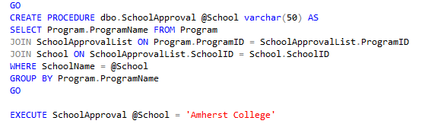

Figure : Procedure – SchoolApproval

For that purpose, the above procedure “SchoolApproval” was used, which stores the school name as a variable and returns this list of programs that are approved by a given college or university.

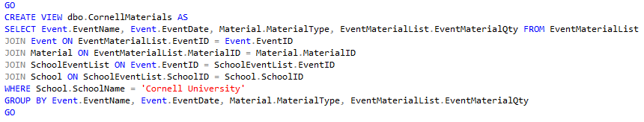

Figure : View – CornellMaterials

In one final example, the above view, “CornellMaterials,” again shows more information about Cornell University. This time, the information provided is with regard to the marketing materials utilized at their study abroad fairs and other events.

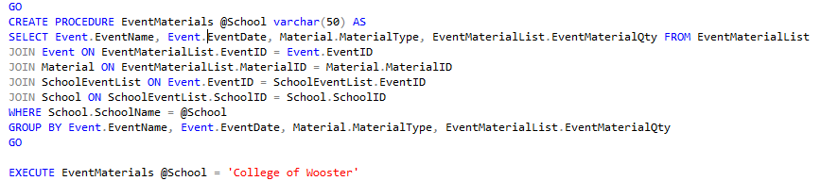

Figure : Procedure – EventMaterials

Much like in previous examples, this is more helpful when utilized as a procedure, because it provides the user with the ability to customize the data based on the partner school of their choosing.

## Answering Data Questions:

Now, utilizing the database I have created, I am able to answer many of the data questions proposed at the outset of the project.

1. Which American institutions send the most students on Syracuse programs?
   1. While I have only added data for 25 of our partner schools, we can see that the school in this sample set that send the most students is Davidson College.

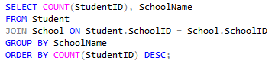

Figure : Code for Count of Students by School

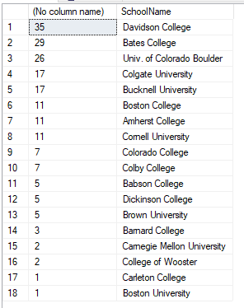

Figure : Count of Students by School

1. Which events require the most material resources?
   1. By summing ordering the event material table by material quantity, we can see that large numbers of viewbooks are required at schools like University of Colorado – Boulder, Cornell University, and Colgate University.

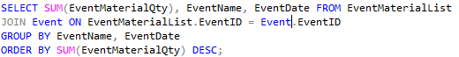

Figure : Code for Sum of EventMaterialQty by School

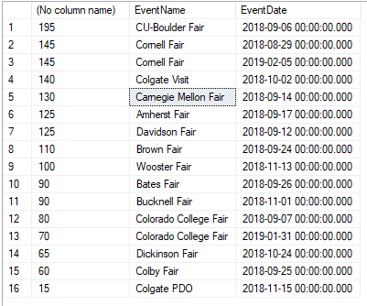

Figure : EventMaterialQty by School

1. Which staff members at partner schools should we contact for various concerns?
   1. By utilizing the “StaffRole” column of the staff table, we are able to designate certain partner school staff members as emergency contacts, or advisers working directly with students. We may find other uses for this column, but the following screenshots demonstrate the current functionality.



Figure : Code for staff members listed as 'Emergency

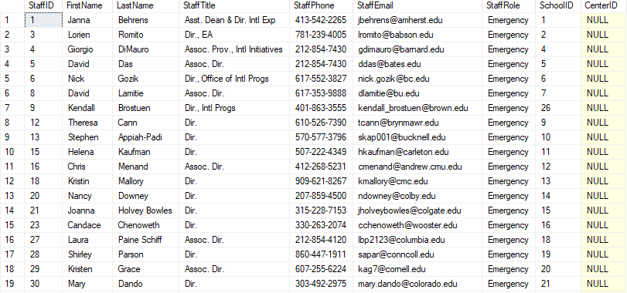

Figure : Emergency contacts

1. How should a given student be billed?
   1. By creating a function that accepts the student’s SystemAppID and returns the billing agreement details, staff members can easily sort out questions for a particular student.

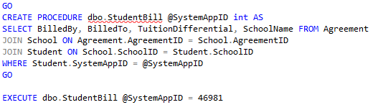

Figure : Code for StudentBill procedure



Figure : StudentBill procedure results for AppID 46981

## Implementation:

By utilizing Open Database Connectivity, I have used Microsoft Access to present a more user-friendly interface for non-SQL users to update.

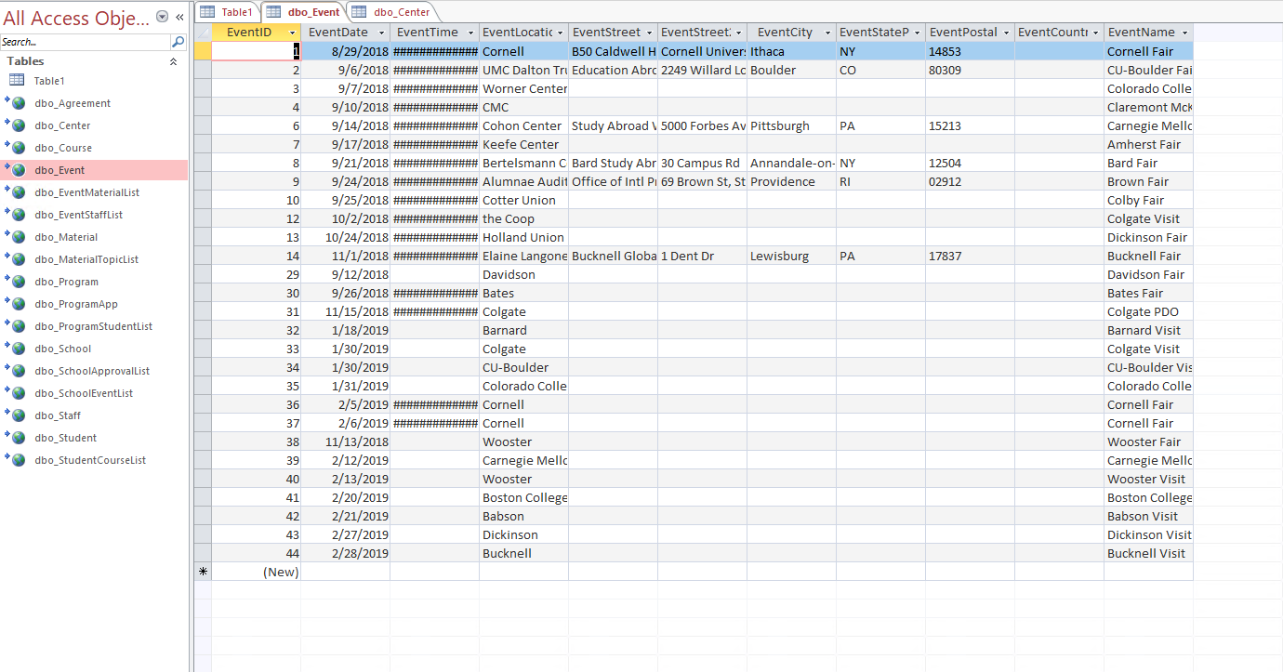

Figure : All tables of Syracuse Abroad database in Access with the Event table open

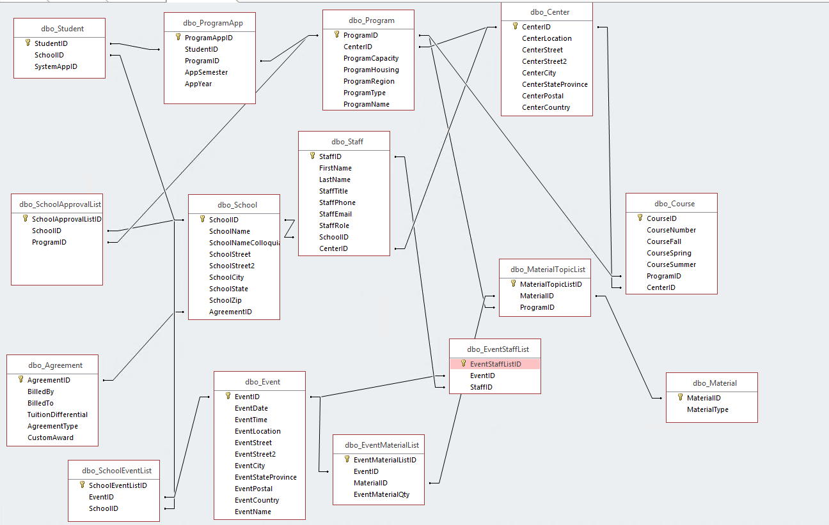

Figure : Relationships as portrayed within Access

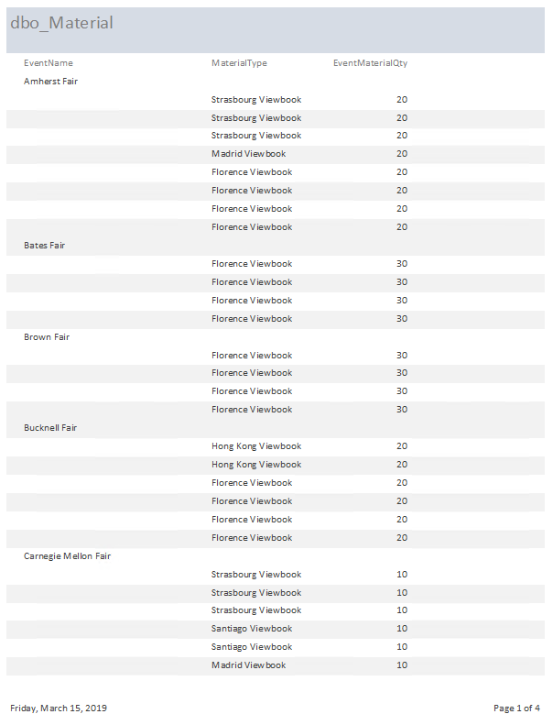

Figure : A report detailing materials used at events

## Reflection:

Coming from a liberal arts background with only one semester of Data Science under my belt, I was interested but skeptical of my own ability to create a functional database using a program I had never used before, SQL. However, going through the process of organizing objects and their relationships to one another clarified the task, and made it easier to conceptualize the end goal from an early stage. While I struggled mightily throughout the process, I found this to be a very enlightening exercise, and one that was meaningful in order to understand what goes into the various SAS application that my office current utilizes, and the improvements that our team and the service providers can make.

I think that I am on the right track in creating a database for Syracuse Abroad’s very specific needs. That said, there is a lot of data fields and relationships that are not necessarily represented in the tables that I populated. As we began the course, we talked and read a lot about consulting with the end users throughout the process to properly gauge their needs. Because this was not destined for actual implementation, I did not have a real business purpose for asking for my colleagues’ help, and there are multiple gaps in the database. This includes entire parts of the business process that are not represented here, as well as specific fields for which I do not have permissions.

This project has been immensely helpful, and I hope that I am able to work with SQL in other courses soon. The language is very intuitive, and I am sure that we have only discovered the tip of the iceberg when it comes to the program’s capabilities.

# SQL script:

-- Creating the School table

CREATE TABLE School (

-- Columns for School table

SchoolID int identity,

SchoolName varchar(50) not null,

SchoolNameColloquial varchar(30) not null,

SchoolStreet varchar(30) not null,

SchoolStreet2 varchar(30),

SchoolCity varchar(30) not null,

SchoolState varchar(2) not null,

SchoolZip varchar(10) not null,

-- Constraints on the School table

CONSTRAINT PK_School PRIMARY KEY (SchoolID),

CONSTRAINT U1_School UNIQUE (SchoolName)

)

-- Creating Center table

CREATE TABLE Center (

-- Columns for Center table

CenterID int identity,

CenterLocation varchar(40) not null,

CenterStreet varchar(30) not null,

CenterStreet2 varchar(30),

CenterCity varchar(30) not null,

CenterStateProvince varchar(15) not null,

CenterPostal varchar(10) not null,

CenterCountry varchar(30) not null,

-- Constraints on the School table

CONSTRAINT PK_Center PRIMARY KEY (CenterID),

CONSTRAINT U1_CenterLocation UNIQUE (CenterLocation),

)

-- Creating Agreement table

CREATE TABLE Agreement (

-- Columns for Agreement table

AgreementID int identity,

BilledBy varchar(30) not null,

BilledTo varchar(30) not null,

TuitionDifferential int not null,

AgreementType varchar(2) not null,

CustomAward int,

-- Constraints on the School table

CONSTRAINT PK_Agreement PRIMARY KEY (AgreementID)

)

-- Creating Material table

CREATE TABLE Material (

-- Columns

MaterialID int identity,

MaterialType varchar(20) not null,

-- Constraints

CONSTRAINT PK_Material PRIMARY KEY (MaterialID)

)

-- Creating Event table

CREATE TABLE Event (

-- Columns

EventID int identity,

EventDate datetime not null,

EventTime datetime,

EventLocation varchar(50) not null,

EventStreet varchar(30),

EventStreet2 varchar(30),

EventCity varchar(30),

EventStateProvince varchar(15),

EventPostal varchar(10),

EventCountry varchar(30),

-- Constraints

CONSTRAINT PK_Event PRIMARY KEY (EventID),

)

ALTER TABLE Event ADD EventName varchar(50)

-- Creating Program table

CREATE TABLE Program (

-- Columns

ProgramID int identity,

CenterID int,

ProgramCapacity int not null,

ProgramHousing varchar(20) not null,

ProgramRegion varchar(20) not null,

ProgramType varchar(20) not null,

-- constraints

CONSTRAINT PK_Program PRIMARY KEY (ProgramID),

CONSTRAINT FK_Program FOREIGN KEY (CenterID) REFERENCES Center(CenterID)

)

ALTER TABLE Program ADD ProgramName varchar(100)

-- Creating Student table

CREATE TABLE Student (

-- Columns

StudentID int identity,

SchoolID int not null

-- constraints

CONSTRAINT PK_Student PRIMARY KEY (StudentID),

CONSTRAINT FK_Student FOREIGN KEY (SchoolID) REFERENCES School(SchoolID)

)

ALTER TABLE Student ADD SystemAppID int

-- Creating Course table

CREATE TABLE Course (

-- Columns

CourseID int identity,

CourseNumber varchar(10) not null,

CourseFall varchar(1) not null,

CourseSpring varchar(1) not null,

CourseSummer varchar(1) not null,

ProgramID int not null,

CenterID int,

-- constraints

CONSTRAINT PK_Course PRIMARY KEY (CourseID),

CONSTRAINT FK_Course FOREIGN KEY (ProgramID) REFERENCES Program(ProgramID),

CONSTRAINT FK2_Course FOREIGN KEY (CenterID) REFERENCES Center(CenterID)

)

-- Updating School table

-- Add Column for Agreement

ALTER TABLE School

ADD AgreementID int

-- Make Agreement foreign key

ALTER TABLE School

ADD CONSTRAINT FK_School FOREIGN KEY (AgreementID) REFERENCES Agreement(AgreementID)

-- Creating ProgramStudentList

CREATE TABLE ProgramStudentList (

ProgramStudentListID int identity,

ProgramID int,

StudentID int,

CONSTRAINT PK_ProgramStudentList PRIMARY KEY (ProgramStudentListID),

CONSTRAINT FK_ProgramStudentList FOREIGN KEY (ProgramID) REFERENCES Program(ProgramID),

CONSTRAINT FK2_ProgramStudentList FOREIGN KEY (StudentID) REFERENCES Student(StudentID)

)

-- Creating SchoolApprovalList

CREATE TABLE SchoolApprovalList (

SchoolApprovalListID int identity,

SchoolID int,

ProgramID int,

CONSTRAINT PK_SchoolApprovalList PRIMARY KEY (SchoolApprovalListID),

CONSTRAINT FK_SchoolApprovalList FOREIGN KEY (SchoolID) REFERENCES School(SchoolID),

CONSTRAINT FK2_SchoolApprovalList FOREIGN KEY (ProgramID) REFERENCES Program(ProgramID)

)

-- adding not null

ALTER TABLE SchoolApprovalList

ALTER COLUMN SchoolID int not null

ALTER TABLE SchoolApprovalList

ALTER COLUMN ProgramID int not null

-- Creating MaterialTopicList

CREATE TABLE MaterialTopicList (

MaterialTopicListID int identity,

MaterialID int,

ProgramID int,

CONSTRAINT PK_MaterialTopicList PRIMARY KEY (MaterialTopicListID),

CONSTRAINT FK_MaterialTopicList FOREIGN KEY (MaterialID) REFERENCES Material(MaterialID),

CONSTRAINT FK2_MaterialTopicList FOREIGN KEY (ProgramID) REFERENCES Program(ProgramID)

)

-- Adding not null

ALTER TABLE MaterialTopicList

ALTER COLUMN MaterialID int not null

-- Creating StudentCourseList

CREATE TABLE StudentCourseList (

StudentCourseListID int identity,

StudentID int,

CourseID int,

CONSTRAINT PK_StudentCourseList PRIMARY KEY (StudentCourseListID),

CONSTRAINT FK_StudentCourseList FOREIGN KEY (StudentID) REFERENCES Student(StudentID),

)

-- Update to include second FK

ALTER TABLE StudentCourseList

ADD CONSTRAINT FK2_StudentCourseList FOREIGN KEY (CourseID) REFERENCES Course(CourseID)

-- Add not null

ALTER TABLE StudentCourseList

ALTER COLUMN StudentID int not null

ALTER TABLE StudentCourseList

ALTER COLUMN CourseID int not null

-- Creating SchoolEventList table

CREATE TABLE SchoolEventList (

SchoolEventListID int identity,

EventID int not null,

SchoolID int not null,

CONSTRAINT PK_SchoolEventList PRIMARY KEY (SchoolEventListID),

CONSTRAINT FK_SchoolEventList FOREIGN KEY (SchoolID) REFERENCES School(SchoolID),

CONSTRAINT FK2_SchoolEventList FOREIGN KEY (EventID) REFERENCES Event(EventID)

)

-- Creating EventMaterialList

CREATE TABLE EventMaterialList (

EventMaterialListID int identity,

EventID int not null,

MaterialID int not null,

EventMaterialQty int not null,

CONSTRAINT PK_EventMaterialList PRIMARY KEY (EventMaterialListID),

CONSTRAINT FK_EventMaterialList FOREIGN KEY (EventID) REFERENCES Event(EventID),

CONSTRAINT FK2_EventMaterialList FOREIGN KEY (MaterialID) REFERENCES Material(MaterialID)

)

-- Creating Staff

CREATE TABLE Staff (

StaffID int identity,

FirstName varchar(20) not null,

LastName varchar(30) not null,

StaffTitle varchar(30) not null,

StaffPhone varchar(15) not null,

StaffEmail varchar(30) not null,

StaffRole varchar(30) not null,

SchoolID int,

CenterID int,

CONSTRAINT PK_Staff PRIMARY KEY (StaffID),

CONSTRAINT FK_Staff FOREIGN KEY (SchoolID) REFERENCES School(SchoolID),

CONSTRAINT FK2_Staff FOREIGN KEY (CenterID) REFERENCES Center(CenterID),

CONSTRAINT U_Staff UNIQUE (StaffEmail)

)

-- Creating EventStaffList

CREATE TABLE EventStaffList (

EventStaffListID int identity,

EventID int,

StaffID int,

CONSTRAINT PK_EventStaffList PRIMARY KEY (EventStaffListID),

CONSTRAINT FK_EventStaffList FOREIGN KEY (EventID) REFERENCES Event(EventID),

CONSTRAINT FK2_EventStaffList FOREIGN KEY (StaffID) REFERENCES Staff(StaffID)

)

-- Application table is missing

DROP TABLE ProgramApp

CREATE TABLE ProgramApp (

ProgramAppID int identity,

StudentID int,

ProgramID int,

AppSemester varchar(10),

AppYear datetime,

CONSTRAINT PK_ProgramApp PRIMARY KEY (ProgramAppID),

CONSTRAINT FK_ProgramApp FOREIGN KEY (ProgramID) REFERENCES Program(ProgramID),

CONSTRAINT FK2_ProgramApp FOREIGN KEY (StudentID) REFERENCES Student(StudentID)

)

-- NEXT STEP: Insert data into all tables

-- a. School

-- A sample of 25 has been entered:

SELECT * FROM School

-- SchoolID, SchoolName, SchoolNameColloquial, SchoolStreet, SchoolStreet2, SchoolCity, SchoolState, SchoolZip, AgreementID

INSERT INTO School(SchoolName, SchoolNameColloquial, SchoolStreet, SchoolCity, SchoolState, SchoolZip, AgreementID)

VALUES ('Amherst College', 'Amherst', '220 Pleasant Street', 'Amherst', 'MA', '01002', 3)

INSERT INTO School(SchoolName, SchoolNameColloquial, SchoolStreet, SchoolCity, SchoolState, SchoolZip, AgreementID)

VALUES ('Babson College', 'Babson', '231 Forest Street', 'Babson Park', 'MA', '02457', 2)

INSERT INTO School(SchoolName, SchoolNameColloquial, SchoolStreet, SchoolCity, SchoolState, SchoolZip, AgreementID)

VALUES ('Bard College', 'Bard', '30 Campus Road', 'Annandale-On-Hudson', 'NY', '12504', 4)

INSERT INTO School(SchoolName, SchoolNameColloquial, SchoolStreet, SchoolCity, SchoolState, SchoolZip, AgreementID)

VALUES ('Barnard College', 'Barnard', '3009 Broadway', 'New York', 'NY', '10027', 2)

INSERT INTO School(SchoolName, SchoolNameColloquial, SchoolStreet, SchoolCity, SchoolState, SchoolZip, AgreementID)

VALUES ('Bates College', 'Bates', '2 Andrews Road', 'Lewiston', 'ME', '04240', 3)

INSERT INTO School(SchoolName, SchoolNameColloquial, SchoolStreet, SchoolCity, SchoolState, SchoolZip, AgreementID)

VALUES ('Boston College', 'BC', '140 Commonwealth Ave', 'Chestnut Hill', 'MA', '02467', 4)

INSERT INTO School(SchoolName, SchoolNameColloquial, SchoolStreet, SchoolCity, SchoolState, SchoolZip, AgreementID)

VALUES ('Boston University', 'BU', '888 Commonwealth Ave', 'Brookline', 'MA', '02446', 4)

INSERT INTO School(SchoolName, SchoolNameColloquial, SchoolStreet, SchoolStreet2, SchoolCity, SchoolState, SchoolZip, AgreementID)

VALUES ('Brown University', 'Brown', 'Brown University', 'Page-Robinson Hall 420', 'Providence', 'RI', 02912, 2)

INSERT INTO School(SchoolName, SchoolNameColloquial, SchoolStreet, SchoolCity, SchoolState, SchoolZip, AgreementID)

VALUES ('Bryn Mawr College', 'Bryn Mawr', '101 N Merion Ave', 'Bryn Mawr', 'PA', '19010', 2)

INSERT INTO School(SchoolName, SchoolNameColloquial, SchoolStreet, SchoolCity, SchoolState, SchoolZip, AgreementID)

VALUES ('Bucknell University', 'Bucknell', '701 Moore Ave', 'Lewisburg', 'PA', '17837', 2)

INSERT INTO School(SchoolName, SchoolNameColloquial, SchoolStreet, SchoolStreet2, SchoolCity, SchoolState, SchoolZip, AgreementID)

VALUES ('Carleton College', 'Carleton', 'Sayles Hill Campus Center', 'North College Street', 'Northfield', 'MN', '55057', 5)

INSERT INTO School(SchoolName, SchoolNameColloquial, SchoolStreet, SchoolCity, SchoolState, SchoolZip, AgreementID)

VALUES ('Carnegie Mellon University', 'Carnegie Mellon', '5000 Forbes Avenue', 'Pittsburgh', 'NY', '15213', 4)

INSERT INTO School(SchoolName, SchoolNameColloquial, SchoolStreet, SchoolCity, SchoolState, SchoolZip, AgreementID)

VALUES ('Claremont McKenna College', 'Claremont McKenna', '888 N Columbia Ave', 'Claremont', 'CA', '91711', 1)

INSERT INTO School(SchoolName, SchoolNameColloquial, SchoolStreet, SchoolCity, SchoolState, SchoolZip, AgreementID)

VALUES ('Colby College', 'Colby', '4000 Mayflower Hill Dr', 'Waterville', 'ME', '04901', 4)

INSERT INTO School(SchoolName, SchoolNameColloquial, SchoolStreet, SchoolCity, SchoolState, SchoolZip, AgreementID)

VALUES ('Colgate University', 'Colgate', '13 Oak Dr', 'Hamilton', 'NY', '13346', 1)

INSERT INTO School(SchoolName, SchoolNameColloquial, SchoolStreet, SchoolCity, SchoolState, SchoolZip, AgreementID)

VALUES ('College of Wooster', 'Wooster', '1189 Beall Ave', 'Wooster', 'OH', '44691', 1)

INSERT INTO School(SchoolName, SchoolNameColloquial, SchoolStreet, SchoolCity, SchoolState, SchoolZip, AgreementID)

VALUES ('Colorado College', 'CC', '14 E Cache La Poudre St', 'Colorado Springs', 'CO', '80903', 1)

INSERT INTO School(SchoolName, SchoolNameColloquial, SchoolStreet, SchoolCity, SchoolState, SchoolZip, AgreementID)

VALUES ('Columbia University', 'Columbia', '116th St & Broadway', 'New York', 'NY', '10027', 2)

INSERT INTO School(SchoolName, SchoolNameColloquial, SchoolStreet, SchoolCity, SchoolState, SchoolZip, AgreementID)

VALUES ('Connecticut College', 'CC', '270 Mohegan Ave', 'New London', 'CT', '06320', 1)

INSERT INTO School(SchoolName, SchoolNameColloquial, SchoolStreet, SchoolStreet2, SchoolCity, SchoolState, SchoolZip, AgreementID)

VALUES ('Cornell University', 'Cornell', 'Caldwell Hall', 'Cornell University', 'Ithaca', 'NY', '14853', 1)

INSERT INTO School(SchoolName, SchoolNameColloquial, SchoolStreet, SchoolStreet2, SchoolCity, SchoolState, SchoolZip, AgreementID)

VALUES ('Univ. of Colorado Boulder', 'CU-Boulder', '123 UCB', 'University of Colorado Bouler', 'Boulder', 'CO', '80309', 1)

INSERT INTO School(SchoolName, SchoolNameColloquial, SchoolStreet, SchoolCity, SchoolState, SchoolZip, AgreementID)

VALUES ('Davidson College', 'Davidson', '405 N Main St', 'Davidson', 'NC', '28035', 3)

INSERT INTO School(SchoolName, SchoolNameColloquial, SchoolStreet, SchoolCity, SchoolState, SchoolZip, AgreementID)

VALUES ('DePaul University', 'DePaul', '1 E Jackson Blvd', 'Chicago', 'IL', '60604', 3)

INSERT INTO School(SchoolName, SchoolNameColloquial, SchoolStreet, SchoolCity, SchoolState, SchoolZip, AgreementID)

VALUES ('Denison University', 'Denison', '100 W College St', 'Granville', 'OH', '43023', 5)

INSERT INTO School(SchoolName, SchoolNameColloquial, SchoolStreet, SchoolCity, SchoolState, SchoolZip, AgreementID)

VALUES ('Dickinson College', 'Dickinson', '28 N College St', 'Carlisle', 'PA', '17013', 1)

-- b. Student

SELECT * FROM Student

-- StudentID, SchoolID

INSERT INTO Student(SystemAppID, SchoolID)

VALUES (47005 ,1)

------

INSERT INTO Student(SystemAppID, SchoolID)

VALUES (47006 ,1)

INSERT INTO Student(SystemAppID, SchoolID)

VALUES (47025 ,1)

INSERT INTO Student(SystemAppID, SchoolID)

VALUES (46008 ,1)

INSERT INTO Student(SystemAppID, SchoolID)

VALUES (51903 ,1)

INSERT INTO Student(SystemAppID, SchoolID)

VALUES (47540 ,1)

INSERT INTO Student(SystemAppID, SchoolID)

VALUES (49469 ,1)

INSERT INTO Student(SystemAppID, SchoolID)

VALUES (49154 ,1)

INSERT INTO Student(SystemAppID, SchoolID)

VALUES (48412 ,1)

INSERT INTO Student(SystemAppID, SchoolID)

VALUES (48485 ,1)

INSERT INTO Student(SystemAppID, SchoolID)

VALUES (48478 ,1)

INSERT INTO Student(SystemAppID, SchoolID)

VALUES (48845 ,2)

INSERT INTO Student(SystemAppID, SchoolID)

VALUES (49437 ,2)

INSERT INTO Student(SystemAppID, SchoolID)

VALUES (49433 ,2)

INSERT INTO Student(SystemAppID, SchoolID)

VALUES (48545 ,2)

INSERT INTO Student(SystemAppID, SchoolID)

VALUES (48769 ,2)

INSERT INTO Student(SystemAppID, SchoolID)

VALUES (45246 ,4)

INSERT INTO Student(SystemAppID, SchoolID)

VALUES (51332 ,4)

INSERT INTO Student(SystemAppID, SchoolID)

VALUES (48736 ,4)

INSERT INTO Student(SystemAppID, SchoolID)

VALUES (47125 ,5)

INSERT INTO Student(SystemAppID, SchoolID)

VALUES (47040 ,5)

INSERT INTO Student(SystemAppID, SchoolID)

VALUES (47226 ,5)

INSERT INTO Student(SystemAppID, SchoolID)

VALUES (47128 ,5)

INSERT INTO Student(SystemAppID, SchoolID)

VALUES (46915 ,5)

INSERT INTO Student(SystemAppID, SchoolID)

VALUES (47127 ,5)

INSERT INTO Student(SystemAppID, SchoolID)

VALUES (46746 ,5)

INSERT INTO Student(SystemAppID, SchoolID)

VALUES (46855 ,5)

INSERT INTO Student(SystemAppID, SchoolID)

VALUES (46996 ,5)

INSERT INTO Student(SystemAppID, SchoolID)

VALUES (47286 ,5)

INSERT INTO Student(SystemAppID, SchoolID)

VALUES (46766 ,5)

INSERT INTO Student(SystemAppID, SchoolID)

VALUES (46968 ,5)

INSERT INTO Student(SystemAppID, SchoolID)

VALUES (46764 ,5)

INSERT INTO Student(SystemAppID, SchoolID)

VALUES (51795 ,5)

INSERT INTO Student(SystemAppID, SchoolID)

VALUES (51858 ,5)

INSERT INTO Student(SystemAppID, SchoolID)

VALUES (51824 ,5)

INSERT INTO Student(SystemAppID, SchoolID)

VALUES (51844 ,5)

INSERT INTO Student(SystemAppID, SchoolID)

VALUES (51842 ,5)

INSERT INTO Student(SystemAppID, SchoolID)

VALUES (47991 ,5)

INSERT INTO Student(SystemAppID, SchoolID)

VALUES (48226 ,5)

INSERT INTO Student(SystemAppID, SchoolID)

VALUES (48112 ,5)

INSERT INTO Student(SystemAppID, SchoolID)

VALUES (48019 ,5)

INSERT INTO Student(SystemAppID, SchoolID)

VALUES (49085 ,5)

INSERT INTO Student(SystemAppID, SchoolID)

VALUES (48242 ,5)

INSERT INTO Student(SystemAppID, SchoolID)

VALUES (48004 ,5)

INSERT INTO Student(SystemAppID, SchoolID)

VALUES (48449 ,5)

INSERT INTO Student(SystemAppID, SchoolID)

VALUES (48034 ,5)

INSERT INTO Student(SystemAppID, SchoolID)

VALUES (48062 ,5)

INSERT INTO Student(SystemAppID, SchoolID)

VALUES (48747 ,5)

INSERT INTO Student(SystemAppID, SchoolID)

VALUES (51468 ,6)

INSERT INTO Student(SystemAppID, SchoolID)

VALUES (51564 ,6)

INSERT INTO Student(SystemAppID, SchoolID)

VALUES (51297 ,6)

INSERT INTO Student(SystemAppID, SchoolID)

VALUES (48192 ,6)

INSERT INTO Student(SystemAppID, SchoolID)

VALUES (47517 ,6)

INSERT INTO Student(SystemAppID, SchoolID)

VALUES (49090 ,6)

INSERT INTO Student(SystemAppID, SchoolID)

VALUES (49476 ,6)

INSERT INTO Student(SystemAppID, SchoolID)

VALUES (48133 ,6)

INSERT INTO Student(SystemAppID, SchoolID)

VALUES (48376 ,6)

INSERT INTO Student(SystemAppID, SchoolID)

VALUES (47561 ,6)

INSERT INTO Student(SystemAppID, SchoolID)

VALUES (48375 ,6)

INSERT INTO Student(SystemAppID, SchoolID)

VALUES (49087 ,7)

INSERT INTO Student(SystemAppID, SchoolID)

VALUES (48767 ,26)

INSERT INTO Student(SystemAppID, SchoolID)

VALUES (47758 ,26)

INSERT INTO Student(SystemAppID, SchoolID)

VALUES (48755 ,26)

INSERT INTO Student(SystemAppID, SchoolID)

VALUES (48104 ,26)

INSERT INTO Student(SystemAppID, SchoolID)

VALUES (49136 ,26)

INSERT INTO Student(SystemAppID, SchoolID)

VALUES (46516 ,10)

INSERT INTO Student(SystemAppID, SchoolID)

VALUES (47091 ,10)

INSERT INTO Student(SystemAppID, SchoolID)

VALUES (46627 ,10)

INSERT INTO Student(SystemAppID, SchoolID)

VALUES (51665 ,10)

INSERT INTO Student(SystemAppID, SchoolID)

VALUES (49374 ,10)

INSERT INTO Student(SystemAppID, SchoolID)

VALUES (48427 ,10)

INSERT INTO Student(SystemAppID, SchoolID)

VALUES (47606 ,10)

INSERT INTO Student(SystemAppID, SchoolID)

VALUES (48675 ,10)

INSERT INTO Student(SystemAppID, SchoolID)

VALUES (48698 ,10)

INSERT INTO Student(SystemAppID, SchoolID)

VALUES (48251 ,10)

INSERT INTO Student(SystemAppID, SchoolID)

VALUES (48346 ,10)

INSERT INTO Student(SystemAppID, SchoolID)

VALUES (48557 ,10)

INSERT INTO Student(SystemAppID, SchoolID)

VALUES (48667 ,10)

INSERT INTO Student(SystemAppID, SchoolID)

VALUES (48750 ,10)

INSERT INTO Student(SystemAppID, SchoolID)

VALUES (48309 ,10)

INSERT INTO Student(SystemAppID, SchoolID)

VALUES (47597 ,10)

INSERT INTO Student(SystemAppID, SchoolID)

VALUES (48353 ,10)

INSERT INTO Student(SystemAppID, SchoolID)

VALUES (45855 ,11)

INSERT INTO Student(SystemAppID, SchoolID)

VALUES (46715 ,12)

INSERT INTO Student(SystemAppID, SchoolID)

VALUES (45805 ,12)

INSERT INTO Student(SystemAppID, SchoolID)

VALUES (46559 ,14)

INSERT INTO Student(SystemAppID, SchoolID)

VALUES (47090 ,14)

INSERT INTO Student(SystemAppID, SchoolID)

VALUES (47089 ,14)

INSERT INTO Student(SystemAppID, SchoolID)

VALUES (46593 ,14)

INSERT INTO Student(SystemAppID, SchoolID)

VALUES (47657 ,14)

INSERT INTO Student(SystemAppID, SchoolID)

VALUES (48163 ,14)

INSERT INTO Student(SystemAppID, SchoolID)

VALUES (48662 ,14)

INSERT INTO Student(SystemAppID, SchoolID)

VALUES (46556 ,15)

INSERT INTO Student(SystemAppID, SchoolID)

VALUES (46191 ,15)

INSERT INTO Student(SystemAppID, SchoolID)

VALUES (45735 ,15)

INSERT INTO Student(SystemAppID, SchoolID)

VALUES (46538 ,15)

INSERT INTO Student(SystemAppID, SchoolID)

VALUES (46773 ,15)

INSERT INTO Student(SystemAppID, SchoolID)

VALUES (46534 ,15)

INSERT INTO Student(SystemAppID, SchoolID)

VALUES (46129 ,15)

INSERT INTO Student(SystemAppID, SchoolID)

VALUES (45752 ,15)

INSERT INTO Student(SystemAppID, SchoolID)

VALUES (46317 ,15)

INSERT INTO Student(SystemAppID, SchoolID)

VALUES (46563 ,15)

INSERT INTO Student(SystemAppID, SchoolID)

VALUES (51572 ,15)

INSERT INTO Student(SystemAppID, SchoolID)

VALUES (51571 ,15)

INSERT INTO Student(SystemAppID, SchoolID)

VALUES (51420 ,15)

INSERT INTO Student(SystemAppID, SchoolID)

VALUES (49604 ,15)

INSERT INTO Student(SystemAppID, SchoolID)

VALUES (48281 ,15)

INSERT INTO Student(SystemAppID, SchoolID)

VALUES (49238 ,15)

INSERT INTO Student(SystemAppID, SchoolID)

VALUES (47937 ,15)

INSERT INTO Student(SystemAppID, SchoolID)

VALUES (48702 ,16)

INSERT INTO Student(SystemAppID, SchoolID)

VALUES (49155 ,16)

INSERT INTO Student(SystemAppID, SchoolID)

VALUES (45755 ,17)

INSERT INTO Student(SystemAppID, SchoolID)

VALUES (47278 ,17)

INSERT INTO Student(SystemAppID, SchoolID)

VALUES (46850 ,17)

INSERT INTO Student(SystemAppID, SchoolID)

VALUES (50669 ,17)

INSERT INTO Student(SystemAppID, SchoolID)

VALUES (51830 ,17)

INSERT INTO Student(SystemAppID, SchoolID)

VALUES (51450 ,17)

INSERT INTO Student(SystemAppID, SchoolID)

VALUES (50359 ,17)

INSERT INTO Student(SystemAppID, SchoolID)

VALUES (47049 ,20)

INSERT INTO Student(SystemAppID, SchoolID)

VALUES (46020 ,20)

INSERT INTO Student(SystemAppID, SchoolID)

VALUES (51657 ,20)

INSERT INTO Student(SystemAppID, SchoolID)

VALUES (48612 ,20)

INSERT INTO Student(SystemAppID, SchoolID)

VALUES (48732 ,20)

INSERT INTO Student(SystemAppID, SchoolID)

VALUES (49022 ,20)

INSERT INTO Student(SystemAppID, SchoolID)

VALUES (49561 ,20)

INSERT INTO Student(SystemAppID, SchoolID)

VALUES (49509 ,20)

INSERT INTO Student(SystemAppID, SchoolID)

VALUES (49249 ,20)

INSERT INTO Student(SystemAppID, SchoolID)

VALUES (49523 ,20)

INSERT INTO Student(SystemAppID, SchoolID)

VALUES (48037 ,20)

INSERT INTO Student(SystemAppID, SchoolID)

VALUES (46283 ,22)

INSERT INTO Student(SystemAppID, SchoolID)

VALUES (46219 ,22)

INSERT INTO Student(SystemAppID, SchoolID)

VALUES (45646 ,22)

INSERT INTO Student(SystemAppID, SchoolID)

VALUES (45903 ,22)

INSERT INTO Student(SystemAppID, SchoolID)

VALUES (45747 ,22)

INSERT INTO Student(SystemAppID, SchoolID)

VALUES (45327 ,22)

INSERT INTO Student(SystemAppID, SchoolID)

VALUES (46078 ,22)

INSERT INTO Student(SystemAppID, SchoolID)

VALUES (46215 ,22)

INSERT INTO Student(SystemAppID, SchoolID)

VALUES (46205 ,22)

INSERT INTO Student(SystemAppID, SchoolID)

VALUES (46251 ,22)

INSERT INTO Student(SystemAppID, SchoolID)

VALUES (46332 ,22)

INSERT INTO Student(SystemAppID, SchoolID)

VALUES (50623 ,22)

INSERT INTO Student(SystemAppID, SchoolID)

VALUES (50515 ,22)

INSERT INTO Student(SystemAppID, SchoolID)

VALUES (50428 ,22)

INSERT INTO Student(SystemAppID, SchoolID)

VALUES (50513 ,22)

INSERT INTO Student(SystemAppID, SchoolID)

VALUES (50633 ,22)

INSERT INTO Student(SystemAppID, SchoolID)

VALUES (50364 ,22)

INSERT INTO Student(SystemAppID, SchoolID)

VALUES (50853 ,22)

INSERT INTO Student(SystemAppID, SchoolID)

VALUES (50605 ,22)

INSERT INTO Student(SystemAppID, SchoolID)

VALUES (50916 ,22)

INSERT INTO Student(SystemAppID, SchoolID)

VALUES (51047 ,22)

INSERT INTO Student(SystemAppID, SchoolID)

VALUES (50646 ,22)

INSERT INTO Student(SystemAppID, SchoolID)

VALUES (50667 ,22)

INSERT INTO Student(SystemAppID, SchoolID)

VALUES (50905 ,22)

INSERT INTO Student(SystemAppID, SchoolID)

VALUES (51145 ,22)

INSERT INTO Student(SystemAppID, SchoolID)

VALUES (51017 ,22)

INSERT INTO Student(SystemAppID, SchoolID)

VALUES (51255 ,22)

INSERT INTO Student(SystemAppID, SchoolID)

VALUES (50860 ,22)

INSERT INTO Student(SystemAppID, SchoolID)

VALUES (50621 ,22)

INSERT INTO Student(SystemAppID, SchoolID)

VALUES (50836 ,22)

INSERT INTO Student(SystemAppID, SchoolID)

VALUES (50854 ,22)

INSERT INTO Student(SystemAppID, SchoolID)

VALUES (50958 ,22)

INSERT INTO Student(SystemAppID, SchoolID)

VALUES (48335 ,22)

INSERT INTO Student(SystemAppID, SchoolID)

VALUES (48996 ,22)

INSERT INTO Student(SystemAppID, SchoolID)

VALUES (48640 ,22)

INSERT INTO Student(SystemAppID, SchoolID)

VALUES (47308 ,25)

INSERT INTO Student(SystemAppID, SchoolID)

VALUES (47268 ,25)

INSERT INTO Student(SystemAppID, SchoolID)

VALUES (46550 ,25)

INSERT INTO Student(SystemAppID, SchoolID)

VALUES (46343 ,25)

INSERT INTO Student(SystemAppID, SchoolID)

VALUES (51266 ,25)

INSERT INTO Student(SystemAppID, SchoolID)

VALUES (46792 ,21)

INSERT INTO Student(SystemAppID, SchoolID)

VALUES (46973 ,21)

INSERT INTO Student(SystemAppID, SchoolID)

VALUES (47014 ,21)

INSERT INTO Student(SystemAppID, SchoolID)

VALUES (46981 ,21)

INSERT INTO Student(SystemAppID, SchoolID)

VALUES (46954 ,21)

INSERT INTO Student(SystemAppID, SchoolID)

VALUES (45904 ,21)

INSERT INTO Student(SystemAppID, SchoolID)

VALUES (46777 ,21)

INSERT INTO Student(SystemAppID, SchoolID)

VALUES (46778 ,21)

INSERT INTO Student(SystemAppID, SchoolID)

VALUES (51333 ,21)

INSERT INTO Student(SystemAppID, SchoolID)

VALUES (51521 ,21)

INSERT INTO Student(SystemAppID, SchoolID)

VALUES (51868 ,21)

INSERT INTO Student(SystemAppID, SchoolID)

VALUES (49510 ,21)

INSERT INTO Student(SystemAppID, SchoolID)

VALUES (48240 ,21)

INSERT INTO Student(SystemAppID, SchoolID)

VALUES (49130 ,21)

INSERT INTO Student(SystemAppID, SchoolID)

VALUES (48178 ,21)

INSERT INTO Student(SystemAppID, SchoolID)

VALUES (48319 ,21)

INSERT INTO Student(SystemAppID, SchoolID)

VALUES (49453 ,21)

INSERT INTO Student(SystemAppID, SchoolID)

VALUES (48708 ,21)

INSERT INTO Student(SystemAppID, SchoolID)

VALUES (48644 ,21)

INSERT INTO Student(SystemAppID, SchoolID)

VALUES (48243 ,21)

INSERT INTO Student(SystemAppID, SchoolID)

VALUES (49183 ,21)

INSERT INTO Student(SystemAppID, SchoolID)

VALUES (49455 ,21)

INSERT INTO Student(SystemAppID, SchoolID)

VALUES (48504 ,21)

INSERT INTO Student(SystemAppID, SchoolID)

VALUES (47539 ,21)

INSERT INTO Student(SystemAppID, SchoolID)

VALUES (47889 ,21)

INSERT INTO Student(SystemAppID, SchoolID)

VALUES (49602 ,21)

-- All student app id numbers entered for fall 18, spring 19, and fall 19 across the sample school population

-- c. Staff

SELECT * FROM Staff

-- StaffID, FirstName, LastName, StaffTitle, StaffPhone, StaffEmail, StaffRole, SchoolID, CenterID

INSERT INTO Staff(FirstName, LastName, StaffTitle, StaffPhone, StaffEmail, StaffRole, SchoolID)

VALUES ('Janna', 'Behrens', 'Asst. Dean & Dir. Intl Exp', '413-542-2265', 'jbehrens@amherst.edu', 'Emergency', 1)

INSERT INTO Staff(FirstName, LastName, StaffTitle, StaffPhone, StaffEmail, SchoolID, StaffRole)

VALUES ('Lo', 'Chow', 'EA Advisor', '781-239-5288', 'lchow@babson.edu', 2, 'Advisor')

INSERT INTO Staff(FirstName, LastName, StaffTitle, StaffPhone, StaffEmail, StaffRole, SchoolID)

VALUES ('Lorien', 'Romito', 'Dir., EA', '781-239-4005', 'lromito@babson.edu', 'Emergency', 2)

INSERT INTO Staff(FirstName, LastName, StaffTitle, StaffPhone, StaffEmail, StaffRole, SchoolID)

VALUES ('Giorgio', 'DiMauro', 'Assoc. Prov., Intl Initiatives', '212-854-7430', 'gdimauro@barnard.edu', 'Emergency', 4)

INSERT INTO Staff(FirstName, LastName, StaffTitle, StaffPhone, StaffEmail, StaffRole, SchoolID)

VALUES ('David', 'Das', 'Assoc. Dir.', '212-854-7430', 'ddas@bates.edu', 'Emergency', 5)

INSERT INTO Staff(FirstName, LastName, StaffTitle, StaffPhone, StaffEmail, StaffRole, SchoolID)

VALUES ('Nick', 'Gozik', 'Dir., Office of Intl Progs', '617-552-3827', 'nick.gozik@bc.edu', 'Emergency', 6)

INSERT INTO Staff(FirstName, LastName, StaffTitle, StaffPhone, StaffEmail, SchoolID, StaffRole)

VALUES ('Nick', 'D India', 'Program Manager', '617-552-3827', 'nicholas.dindia@bc.edu', 6, 'Advisor')

INSERT INTO Staff(FirstName, LastName, StaffTitle, StaffPhone, StaffEmail, StaffRole, SchoolID)

VALUES ('David', 'Lamitie', 'Assoc. Dir.', '617-353-9888', 'dlamitie@bu.edu', 'Emergency', 7)

INSERT INTO Staff(FirstName, LastName, StaffTitle, StaffPhone, StaffEmail, StaffRole, SchoolID)

VALUES ('Kendall', 'Brostuen', 'Dir., Intl Progs', '401-863-3555', 'kendall_brostuen@brown.edu', 'Emergency', 26)

INSERT INTO Staff(FirstName, LastName, StaffTitle, StaffPhone, StaffEmail, SchoolID, StaffRole)

VALUES ('Lynn', 'Cavicchi', 'Program Manager', '401-863-3555', 'lynn_cavicchi@brown.edu', 26, 'Advisor')

INSERT INTO Staff(FirstName, LastName, StaffTitle, StaffPhone, StaffEmail, SchoolID, StaffRole)

VALUES ('Ned', 'Quigley', 'Assoc. Dir.', '401-863-2906', 'ned_quigley@brown.edu', 26, 'other')

INSERT INTO Staff(FirstName, LastName, StaffTitle, StaffPhone, StaffEmail, StaffRole, SchoolID)

VALUES ('Theresa', 'Cann', 'Dir.', '610-526-7390', 'tcann@brynmawr.edu', 'Emergency', 9)

INSERT INTO Staff(FirstName, LastName, StaffTitle, StaffPhone, StaffEmail, StaffRole, SchoolID)

VALUES ('Stephen', 'Appiah-Padi', 'Dir.', '570-577-3796', 'skap001@bucknell.edu', 'Emergency', 10)

INSERT INTO Staff(FirstName, LastName, StaffTitle, StaffPhone, StaffEmail, SchoolID, StaffRole)

VALUES ('Jen', 'Ellis Fritz', 'Assoc. Dir.', '570-577-3743', 'j.ellis.fritz@bucknell.edu', 10, 'Emergency')

INSERT INTO Staff(FirstName, LastName, StaffTitle, StaffPhone, StaffEmail, StaffRole, SchoolID)

VALUES ('Helena', 'Kaufman', 'Dir.', '507-222-4349', 'hkaufman@carleton.edu', 'Emergency', 11)

INSERT INTO Staff(FirstName, LastName, StaffTitle, StaffPhone, StaffEmail, StaffRole, SchoolID)

VALUES ('Chris', 'Menand', 'Assoc. Dir.', '412-268-5231', 'cmenand@andrew.cmu.edu', 'Emergency', 12)

INSERT INTO Staff(FirstName, LastName, StaffTitle, StaffPhone, StaffEmail, SchoolID, StaffRole)

VALUES ('Jasmine', 'Watson', 'Asst. Dir.', '909-621-8267', 'jwatson@cmc.edu', 13, 'other')

INSERT INTO Staff(FirstName, LastName, StaffTitle, StaffPhone, StaffEmail, StaffRole, SchoolID)

VALUES ('Kristin', 'Mallory', 'Dir.', '909-621-8267', 'kmallory@cmc.edu', 'Emergency', 13)

INSERT INTO Staff(FirstName, LastName, StaffTitle, StaffPhone, StaffEmail, SchoolID, StaffRole)

VALUES ('Eva', 'McVicar', 'Assoc. Dir.', '207-859-4500', 'emcvicar@colby.edu', 14, 'other')

INSERT INTO Staff(FirstName, LastName, StaffTitle, StaffPhone, StaffEmail, StaffRole, SchoolID)

VALUES ('Nancy', 'Downey', 'Dir.', '207-859-4500', 'ndowney@colby.edu', 'Emergency', 14)

INSERT INTO Staff(FirstName, LastName, StaffTitle, StaffPhone, StaffEmail, StaffRole, SchoolID)

VALUES ('Joanna', 'Holvey Bowles', 'Dir.', '315-228-7153', 'jholveybowles@colgate.edu', 'Emergency', 15)

INSERT INTO Staff(FirstName, LastName, StaffTitle, StaffPhone, StaffEmail, SchoolID, StaffRole)

VALUES ('Cas', 'Sowa', 'Assoc. Dir.', '315-228-7160', 'csowa@colgate', 15, 'other')

INSERT INTO Staff(FirstName, LastName, StaffTitle, StaffPhone, StaffEmail, StaffRole, SchoolID)

VALUES ('Candace', 'Chenoweth', 'Dir.', '330-263-2074', 'cchenoweth@wooster.edu', 'Emergency', 16)

INSERT INTO Staff(FirstName, LastName, StaffTitle, StaffPhone, StaffEmail, SchoolID, StaffRole)

VALUES ('Jamie', 'Adler', 'Asst. Dir.', '330-263-2221', 'jadler@wooster.edu', 16, 'Advisor')

INSERT INTO Staff(FirstName, LastName, StaffTitle, StaffPhone, StaffEmail, StaffRole, SchoolID)

VALUES ('Heather', 'Browne', 'Asst. Dir.', '719-389-6918', 'heather.browne@', 'Emergency', 17)

INSERT INTO Staff(FirstName, LastName, StaffTitle, StaffPhone, StaffEmail, SchoolID, StaffRole)

VALUES ('Jill', 'Burya', 'Assoc. Dir.', '212-854-4120', 'jb3412@columbia.edu', 18, 'other')

INSERT INTO Staff(FirstName, LastName, StaffTitle, StaffPhone, StaffEmail, StaffRole, SchoolID)

VALUES ('Laura', 'Paine Schiff', 'Assoc. Dir.', '212-854-4120', 'lbp2123@columbia.edu', 'Emergency', 18)

INSERT INTO Staff(FirstName, LastName, StaffTitle, StaffPhone, StaffEmail, StaffRole, SchoolID)

VALUES ('Shirley', 'Parson', 'Dir.', '860-447-1911', 'sapar@conncoll.edu', 'Emergency', 19)

INSERT INTO Staff(FirstName, LastName, StaffTitle, StaffPhone, StaffEmail, StaffRole, SchoolID)

VALUES ('Kristen', 'Grace', 'Assoc. Dir.', '607-255-6224', 'kag7@cornell.edu', 'Emergency', 20)

INSERT INTO Staff(FirstName, LastName, StaffTitle, StaffPhone, StaffEmail, StaffRole, SchoolID)

VALUES ('Mary', 'Dando', 'Dir.', '303-492-2975', 'mary.dando@colorado.edu', 'Emergency', 21)

INSERT INTO Staff(FirstName, LastName, StaffTitle, StaffPhone, StaffEmail, StaffRole, SchoolID)

VALUES ('Allie', 'Nunes', 'Asst. Dir.', '303-735-0279', 'alexandra.nunes@colorado.edu', 'Emergency', 21)

INSERT INTO Staff(FirstName, LastName, StaffTitle, StaffPhone, StaffEmail, StaffRole, SchoolID)

VALUES ('Naomi', 'Otterness', 'Dir.', '704-894-2250', 'naotterness@davidson.edu', 'Emergency', 22)

INSERT INTO Staff(FirstName, LastName, StaffTitle, StaffPhone, StaffEmail, SchoolID, StaffRole)

VALUES ('Abby', 'Naglosky', 'Asst. Dir.', '704-894-2455', 'abcardona@davidson.edu', 22, 'Advisor')

INSERT INTO Staff(FirstName, LastName, StaffTitle, StaffPhone, StaffEmail, SchoolID, StaffRole)

VALUES ('Evan', 'Owen', 'EA Advisor', '704-894-2128', 'evowen@davidson.edu', 22, 'Advisor')

INSERT INTO Staff(FirstName, LastName, StaffTitle, StaffPhone, StaffEmail, StaffRole, SchoolID)

VALUES ('Martha', 'McGivern', 'Dir.', '312-362-6962', 'martha.mcgivern@depaul.edu', 'Emergency', 23)

INSERT INTO Staff(FirstName, LastName, StaffTitle, StaffPhone, StaffEmail, StaffRole, SchoolID)

VALUES ('Katy', 'Crossley-Frolick', 'Dir.', '740-587-6532', 'frolickk@denison.edu', 'Emergency', 24)

INSERT INTO Staff(FirstName, LastName, StaffTitle, StaffPhone, StaffEmail, StaffRole, SchoolID)

VALUES ('Sam', 'Brandauer', 'Exec. Dir.', '717-254-8068', 'brandaus@dickinson.edu', 'Emergency', 25)

INSERT INTO Staff(FirstName, LastName, StaffTitle, StaffPhone, StaffEmail, SchoolID, StaffRole)

VALUES ('Stephanie', 'Gulden', 'Advisor', '717-245-1769', 'guldens@dickinson.edu', 25, 'Advisor')

-- all values entered for sample school set

-- internal sua staff:

INSERT INTO Staff(FirstName, LastName, StaffTitle, StaffPhone, StaffEmail, StaffRole)

VALUES('Matt', 'Maloney', 'Recruiter', '315-443-9427', 'msmal100@syr.edu', 'IR TEAM')

INSERT INTO Staff(FirstName, LastName, StaffTitle, StaffPhone, StaffEmail, StaffRole)

VALUES('Lou', 'Berends', 'Dir. Strat. Intl. Part.', '315-443-1925', 'lmberend@syr.edu', 'IR TEAM')

INSERT INTO Staff(FirstName, LastName, StaffTitle, StaffPhone, StaffEmail, StaffRole)

VALUES('Ray', 'Wihak', 'Assist. Dir. IR', '315-443-9426', 'rwwiahk@syr.edu', 'IR TEAM')

INSERT INTO Staff(FirstName, LastName, StaffTitle, StaffPhone, StaffEmail, StaffRole)

VALUES('Petra', 'Hejnova', 'Dir. Curriculum', '315-443-9418', 'phejnova@syr.edu', 'Coverage')

INSERT INTO Staff(FirstName, LastName, StaffTitle, StaffPhone, StaffEmail, StaffRole)

VALUES('Mary', 'Fedorko', 'Asst. Dir. Admissions', '315-443-9424', 'mmfedork@syr.edu', 'Coverage')

SELECT * FROM Staff WHERE StaffID > 53

-- d. Event

SELECT * FROM Event

-- EventID, EventName, EventDate, EventTime, EventLocation, EventStreet, EventStreet2, EventCity, EventStateProvince, EventPostal, EventCountry

INSERT INTO Event(EventName, EventDate, EventTime, EventLocation, EventStreet, EventStreet2, EventCity, EventStateProvince, EventPostal)

VALUES ('Cornell Fair', '2018-08-29', '11:30:00', 'Cornell', 'B50 Caldwell Hall', 'Cornell University', 'Ithaca', 'NY', '14853')

INSERT INTO Event(EventName, EventDate, EventTime, EventLocation, EventStreet, EventStreet2, EventCity, EventStateProvince, EventPostal)

VALUES ('CU-Boulder Fair', '2018-09-06', '10:30:00', 'UMC Dalton Trumbo Fountain', 'Education Abroad', '2249 Willard Loop Dr', 'Boulder', 'CO', '80309')

INSERT INTO Event(EventName, EventDate, EventTime, EventLocation)

VALUES ('Colorado College Fair', '2018-09-07', '11:30:00', 'Worner Center')

INSERT INTO Event(EventName, EventDate, EventTime, EventLocation)

VALUES ('Claremont McKenna Visit', '2018-09-10', '10:00:00', 'CMC')

INSERT INTO Event(EventName, EventDate, EventLocation)

VALUES ('Davidson Fair', '2018-09-12', 'Davidson')

INSERT INTO Event(EventName, EventDate, EventTime, EventLocation, EventStreet, EventStreet2, EventCity, EventStateProvince, EventPostal)

VALUES ('Carnegie Mellon Fair', '2018-09-14', '11:00:00', 'Cohon Center', 'Study Abroad Warner 3rd Fl', '5000 Forbes Ave', 'Pittsburgh', 'PA', '15213')

INSERT INTO Event(EventName, EventDate, EventTime, EventLocation)

VALUES ('Amherst Fair', '2018-09-17', '16:00:00', 'Keefe Center')

INSERT INTO Event(EventName, EventDate, EventTime, EventLocation, EventStreet, EventStreet2, EventCity, EventStateProvince, EventPostal)

VALUES ('Bard Fair', '2018-09-21', '14:30:00', 'Bertelsmann Center', 'Bard Study Abroad', '30 Campus Rd', 'Annandale-on-Hudson', 'NY', '12504')

INSERT INTO Event(EventName, EventDate, EventTime, EventLocation, EventStreet, EventStreet2, EventCity, EventStateProvince, EventPostal)

VALUES ('Brown Fair', '2018-09-24', '11:00:00', 'Alumnae Auditorium', 'Office of Intl Progs', '69 Brown St, Ste 420', 'Providence', 'RI', '02912')

INSERT INTO Event(EventName, EventDate, EventTime, EventLocation)

VALUES ('Colby Fair', '2018-09-25', '15:00:00', 'Cotter Union')

INSERT INTO Event(EventName, EventDate, EventTime, EventLocation)

VALUES ('Bates Fair', '2018-09-26', '11:00:00', 'Bates')

INSERT INTO Event(EventName, EventDate, EventTime, EventLocation)

VALUES ('Colgate Visit', '2018-10-02', '16:30:00', 'the Coop')

INSERT INTO Event(EventName, EventDate, EventTime, EventLocation)

VALUES ('Dickinson Fair', '2018-10-24', '17:00:00', 'Holland Union')

INSERT INTO Event(EventName, EventDate, EventTime, EventLocation, EventStreet, EventStreet2, EventCity, EventStateProvince, EventPostal)

VALUES ('Bucknell Fair', '2018-11-01', '11:00:00', 'Elaine Langone', 'Bucknell Global Education', '1 Dent Dr', 'Lewisburg', 'PA', '17837')

INSERT INTO Event(EventName, EventDate, EventTime, EventLocation)

VALUES ('Colgate PDO', '2018-11-15', '12:00:00', 'Colgate')

INSERT INTO Event(EventName, EventDate, EventLocation)

VALUES ('Barnard Visit', '2019-01-18', 'Barnard')

INSERT INTO Event(EventName, EventDate, EventLocation)

VALUES ('Colgate Visit', '2019-01-30', 'Colgate')

INSERT INTO Event(EventName, EventDate, EventLocation)

VALUES ('CU-Boulder Visit', '2019-01-30', 'CU-Boulder')

INSERT INTO Event(EventName, EventDate, EventLocation)

VALUES ('Colorado College Fair', '2019-01-31', 'Colorado College')

INSERT INTO Event(EventName, EventDate, EventTime, EventLocation)

VALUES ('Cornell Fair', '2019-02-05', '10:00:00', 'Cornell')

INSERT INTO Event(EventName, EventDate, EventTime, EventLocation)

VALUES ('Cornell Fair', '2019-02-06', '10:00:00', 'Cornell')

INSERT INTO Event(EventName, EventDate, EventLocation)

VALUES ('Wooster Fair', '2018-11-13', 'Wooster')

INSERT INTO Event(EventName, EventDate, EventLocation)

VALUES ('Carnegie Mellon Visit', '2019-02-12', 'Carnegie Mellon')

INSERT INTO Event(EventName, EventDate, EventLocation)

VALUES ('Wooster Visit', '2019-02-13', 'Wooster')

INSERT INTO Event(EventName, EventDate, EventLocation)

VALUES ('Boston College Visit', '2019-02-20', 'Boston College')

INSERT INTO Event(EventName, EventDate, EventLocation)

VALUES ('Babson Visit', '2019-02-21', 'Babson')

INSERT INTO Event(EventName, EventDate, EventLocation)

VALUES ('Dickinson Visit', '2019-02-27', 'Dickinson')

INSERT INTO Event(EventName, EventDate, EventLocation)

VALUES ('Bucknell Visit', '2019-02-28', 'Bucknell')

-- All 2018-2019 AY fairs and visits entered

-- e. Material

SELECT * FROM Material

-- MaterialID, MaterialType

-- Values added through 'Visiting Inquiry'

INSERT INTO Material(MaterialType)

VALUES ('Florence Viewbook')

INSERT INTO Material(MaterialType)

VALUES ('Hong Kong Viewbook')

INSERT INTO Material(MaterialType)

VALUES ('London Viewbook')

INSERT INTO Material(MaterialType)

VALUES ('Madrid Viewbook')

INSERT INTO Material(MaterialType)

VALUES ('Santiago Viewbook')

INSERT INTO Material(MaterialType)

VALUES ('Strasbourg Viewbook')

INSERT INTO Material(MaterialType)

VALUES ('Summer Viewbook')

INSERT INTO Material(MaterialType)

VALUES ('ECE Viewbook')

INSERT INTO Material(MaterialType)

VALUES ('Study Abroad 101')

INSERT INTO Material(MaterialType)

VALUES ('Pen')

INSERT INTO Material(MaterialType)

VALUES ('Canvas Bag')

INSERT INTO Material(MaterialType)

VALUES ('Florence Sticker')

INSERT INTO Material(MaterialType)

VALUES ('Hong Kong Sticker')

INSERT INTO Material(MaterialType)

VALUES ('London Sticker')

INSERT INTO Material(MaterialType)

VALUES ('Madrid Sticker')

INSERT INTO Material(MaterialType)

VALUES ('Strasbourg Sticker')

INSERT INTO Material(MaterialType)

VALUES ('Santiago Sticker')

INSERT INTO Material(MaterialType)

VALUES ('Luggage Tag')

INSERT INTO Material(MaterialType)

VALUES ('Fast Facts')

INSERT INTO Material(MaterialType)

VALUES ('SU Inquiry')

INSERT INTO Material(MaterialType)

VALUES ('Visiting Inquiry')

-- f. Program

SELECT * FROM Program

-- ProgramID, CenterID, ProgramCapacity, ProgramHousing, ProgramRegion, ProgramType

-- Florence 1, Madrid 2, London 3, Strasbourg 4, Hong Kong 6, Santiago 7

INSERT INTO Program(ProgramName, CenterID, ProgramCapacity, ProgramHousing, ProgramRegion, ProgramType)

VALUES ('Syracuse Florence Center', 1, 245, 'HS', 'Florence', 'Semester')

INSERT INTO Program(ProgramName, CenterID, ProgramCapacity, ProgramHousing, ProgramRegion, ProgramType)

VALUES ('Syracuse Florence Architecture', 1, 25, 'HS/Apt', 'Florence', 'Semester')

INSERT INTO Program(ProgramName, CenterID, ProgramCapacity, ProgramHousing, ProgramRegion, ProgramType)

VALUES ('Syracuse Florence Design', 1, 25, 'HS', 'Florence', 'Semester')

INSERT INTO Program(ProgramName, CenterID, ProgramCapacity, ProgramHousing, ProgramRegion, ProgramType)

VALUES ('Syracuse Florence Studio Arts', 1, 25, 'HS/Apt', 'Florence', 'Semester')

INSERT INTO Program(ProgramName, CenterID, ProgramCapacity, ProgramHousing, ProgramRegion, ProgramType)

VALUES ('Syracuse Madrid Center', 2, 150, 'HS/Dorm', 'Madrid', 'Semester')

INSERT INTO Program(ProgramName, CenterID, ProgramCapacity, ProgramHousing, ProgramRegion, ProgramType)

VALUES ('Syracuse London Center', 3, 180, 'Flat', 'London', 'Semester')

INSERT INTO Program(ProgramName, CenterID, ProgramCapacity, ProgramHousing, ProgramRegion, ProgramType)

VALUES ('Syracuse London Design', 3, 25, 'Flat', 'London', 'Semester')

INSERT INTO Program(ProgramName, CenterID, ProgramCapacity, ProgramHousing, ProgramRegion, ProgramType)

VALUES ('Syracuse London Architecture', 3, 25, 'Flat', 'London', 'Semester')

INSERT INTO Program(ProgramName, CenterID, ProgramCapacity, ProgramHousing, ProgramRegion, ProgramType)

VALUES ('Syracuse London Acting', 3, 20, 'Flat', 'London', 'Semester')

INSERT INTO Program(ProgramName, CenterID, ProgramCapacity, ProgramHousing, ProgramRegion, ProgramType)

VALUES ('Syracuse Strasbourg Center', 4, 50, 'HS', 'Strasbourg', 'Semester')

INSERT INTO Program(ProgramName, CenterID, ProgramCapacity, ProgramHousing, ProgramRegion, ProgramType)

VALUES ('Syracuse Strasbourg Engineering', 4, 20, 'HS', 'Strasbourg', 'Semester')

INSERT INTO Program(ProgramName, CenterID, ProgramCapacity, ProgramHousing, ProgramRegion, ProgramType)

VALUES ('Syracuse Strasbourg Music', 4, 20, 'HS', 'Strasbourg', 'Semester')

INSERT INTO Program(ProgramName, CenterID, ProgramCapacity, ProgramHousing, ProgramRegion, ProgramType)

VALUES ('Syracuse Hong Kong Center', 6, 65, 'Apt', 'Hong Kong', 'Semester')

INSERT INTO Program(ProgramName, CenterID, ProgramCapacity, ProgramHousing, ProgramRegion, ProgramType)

VALUES ('Syracuse Hong Kong: City U', 6, 5, 'Apt/Dorm', 'Hong Kong', 'Semester')

INSERT INTO Program(ProgramName, CenterID, ProgramCapacity, ProgramHousing, ProgramRegion, ProgramType)

VALUES ('Syracuse Santiago Center', 7, 18, 'HS', 'Santiago', 'Semester')

INSERT INTO Program(ProgramName, CenterID, ProgramCapacity, ProgramHousing, ProgramRegion, ProgramType)

VALUES ('Syracuse Santiago Center: Cuenca Immersion', 7, 7, 'HS', 'Santiago', 'Semester')

-- All center program tracks updated

-- g. Center

SELECT * FROM Center

-- This has been completed

-- CenterID, CenterLocation, CenterStreet, CenterStreet2, CenterCity, CenterStateProvince, CenterPostal, CenterCountry

INSERT INTO Center(CenterLocation, CenterStreet, CenterCity, CenterStateProvince, CenterPostal, CenterCountry)

VALUES ('Florence', 'Piazza Savonarola 15', 'Florence', 'FI', '50132', 'Italy')

INSERT INTO Center(CenterLocation, CenterStreet, CenterCity, CenterStateProvince, CenterPostal, CenterCountry)

VALUES ('Madrid', 'C/ Miguel Angel, 8', 'Madrid', 'MD', '28010', 'Spain')

INSERT INTO Center(CenterLocation, CenterStreet, CenterCity, CenterStateProvince, CenterPostal, CenterCountry)

VALUES ('London', '48-51 Old Gloucester Street', 'London', 'London', 'WC1N 3AE', 'United Kingdom')

INSERT INTO Center(CenterLocation, CenterStreet, CenterCity, CenterStateProvince, CenterPostal, CenterCountry)

VALUES ('Strasbourg', '19 Quai de Rouget-de-Lisle', 'Strasbourg', 'Bas-Rhin', '6700', 'France')

INSERT INTO Center(CenterLocation, CenterStreet, CenterStreet2, CenterCity, CenterStateProvince, CenterPostal, CenterCountry)

VALUES ('Santiago', 'Syracuse University', 'Av. J Guzman 3300', 'Santiago', 'RM', '7750000', 'Chile')

INSERT INTO Center(CenterLocation, CenterStreet, CenterCity, CenterStateProvince, CenterPostal, CenterCountry)

VALUES ('Hong Kong', 'Jockey Club Envir. Bldg.', '77 Tat Chee Ave', 'Kowloon Tong', 'Kowloon', 'Hong Kong')

-- h. Agreement

-- This has all been added:

SELECT * FROM Agreement

-- AgreementID, BilledBy, BilledTo, TuitionDifferential, AgreementType, CustomAward

INSERT INTO Agreement (BilledBy, BilledTo, TuitionDifferential, AgreementType)

VALUES ('Syracuse', 'Institution', 6400, 'D')

INSERT INTO Agreement (BilledBy, BilledTo, TuitionDifferential, AgreementType)

VALUES ('Syracuse', 'Institution', 4600, 'S')

INSERT INTO Agreement (BilledBy, BilledTo, TuitionDifferential, AgreementType)

VALUES ('Syracuse', 'Student', 6400, 'A')

INSERT INTO Agreement (BilledBy, BilledTo, TuitionDifferential, AgreementType)

VALUES ('Syracuse', 'Student', 5700, 'T')

INSERT INTO Agreement (BilledBy, BilledTo, TuitionDifferential, AgreementType)

VALUES ('Syracuse', 'Student', 1000, 'N')

-- i. Course

SELECT * FROM Course

SELECT * FROM Program

-- Florence Center - 1, Florence Arch - 2, Florence Design - 3, Florence Studio Arts - 4

-- Madrid Center - 5, London Center - 6, London Design - 7, London Arch - 8, London Acting - 9

-- Strasbourg Center - 10, Strasbourg Eng. - 11, Strasbourg Music - 12

-- Hong Kong Center - 13, Hong Kong City U - 14, Santiago Center - 15, Santiago + Cuenca - 16

-- Florence - 1, Madrid - 2, London - 3, Strasbourg - 4, Hong Kong - 6, Santiago - 7

-- CourseID, CourseNumber, CourseFall, CourseSpring, CourseSummer, ProgramID, CenterID

INSERT INTO Course(CourseNumber, CourseFall, CourseSpring, CourseSummer, ProgramID, CenterID)

VALUES ('ANT409', 'Y', 'N', 'N', 1, 1)

INSERT INTO Course(CourseNumber, CourseFall, CourseSpring, CourseSummer, ProgramID, CenterID)

VALUES ('ANT422', 'Y', 'Y', 'N', 1, 1)

INSERT INTO Course(CourseNumber, CourseFall, CourseSpring, CourseSummer, ProgramID, CenterID)

VALUES ('ARC332', 'Y', 'Y', 'N', 2, 1)

INSERT INTO Course(CourseNumber, CourseFall, CourseSpring, CourseSummer, ProgramID, CenterID)

VALUES ('ARC335', 'Y', 'Y', 'N', 2, 1)

-- ** above courses have been entered

INSERT INTO Course(CourseNumber, CourseFall, CourseSpring, CourseSummer, ProgramID, CenterID)

VALUES ('ARC407', 'Y', 'Y', 'N', 2, 1)

INSERT INTO Course(CourseNumber, CourseFall, CourseSpring, CourseSummer, ProgramID, CenterID)

VALUES ('ARC408', 'Y', 'Y', 'N', 2, 1)

INSERT INTO Course(CourseNumber, CourseFall, CourseSpring, CourseSummer, ProgramID, CenterID)

VALUES ('HOA203', 'Y', 'Y', 'N', 1, 1)

INSERT INTO Course(CourseNumber, CourseFall, CourseSpring, CourseSummer, ProgramID, CenterID)

VALUES ('HOA303', 'Y', 'Y', 'N', 1, 1)

INSERT INTO Course(CourseNumber, CourseFall, CourseSpring, CourseSummer, ProgramID, CenterID)

VALUES ('HOA320', 'Y', 'Y', 'N', 1, 1)

INSERT INTO Course(CourseNumber, CourseFall, CourseSpring, CourseSummer, ProgramID, CenterID)

VALUES ('HOA322', 'Y', 'Y', 'N', 1, 1)

INSERT INTO Course(CourseNumber, CourseFall, CourseSpring, CourseSummer, ProgramID, CenterID)

VALUES ('ARI231', 'Y', 'Y', 'N', 4, 1)

INSERT INTO Course(CourseNumber, CourseFall, CourseSpring, CourseSummer, ProgramID, CenterID)

VALUES ('ARI333', 'Y', 'Y', 'N', 4, 1)

INSERT INTO Course(CourseNumber, CourseFall, CourseSpring, CourseSummer, ProgramID, CenterID)

VALUES ('ARI467', 'Y', 'Y', 'N', 4, 1)

INSERT INTO Course(CourseNumber, CourseFall, CourseSpring, CourseSummer, ProgramID, CenterID)

VALUES ('DES485', 'N', 'Y', 'N', 3, 1)

INSERT INTO Course(CourseNumber, CourseFall, CourseSpring, CourseSummer, ProgramID, CenterID)

VALUES ('CMD450', 'N', 'Y', 'N', 3, 1)

INSERT INTO Course(CourseNumber, CourseFall, CourseSpring, CourseSummer, ProgramID, CenterID)

VALUES ('ANT381', 'Y', 'Y', 'N', 5, 2)

INSERT INTO Course(CourseNumber, CourseFall, CourseSpring, CourseSummer, ProgramID, CenterID)

VALUES ('HOA209', 'Y', 'Y', 'N', 5, 2)

INSERT INTO Course(CourseNumber, CourseFall, CourseSpring, CourseSummer, ProgramID, CenterID)

VALUES ('HOA464', 'Y', 'Y', 'N', 5, 2)

INSERT INTO Course(CourseNumber, CourseFall, CourseSpring, CourseSummer, ProgramID, CenterID)

VALUES ('BIO312', 'Y', 'Y', 'Y', 5, 2)

INSERT INTO Course(CourseNumber, CourseFall, CourseSpring, CourseSummer, ProgramID, CenterID)

VALUES ('ECN361', 'Y', 'Y', 'N', 5, 2)

INSERT INTO Course(CourseNumber, CourseFall, CourseSpring, CourseSummer, ProgramID, CenterID)

VALUES ('ECN365', 'Y', 'Y', 'N', 5, 2)

INSERT INTO Course(CourseNumber, CourseFall, CourseSpring, CourseSummer, ProgramID, CenterID)

VALUES ('EAR105', 'Y', 'Y', 'N', 5, 2)

INSERT INTO Course(CourseNumber, CourseFall, CourseSpring, CourseSummer, ProgramID, CenterID)

VALUES ('ENG320', 'Y', 'Y', 'N', 5, 2)

INSERT INTO Course(CourseNumber, CourseFall, CourseSpring, CourseSummer, ProgramID, CenterID)

VALUES ('HST322', 'Y', 'Y', 'N', 5, 2)

INSERT INTO Course(CourseNumber, CourseFall, CourseSpring, CourseSummer, ProgramID, CenterID)

VALUES ('HUM321', 'Y', 'Y', 'N', 5, 2)

INSERT INTO Course(CourseNumber, CourseFall, CourseSpring, CourseSummer, ProgramID, CenterID)

VALUES ('QSX306', 'Y', 'Y', 'N', 5, 2)

INSERT INTO Course(CourseNumber, CourseFall, CourseSpring, CourseSummer, ProgramID, CenterID)

VALUES ('ADV206', 'Y', 'Y', 'N', 6, 3)

INSERT INTO Course(CourseNumber, CourseFall, CourseSpring, CourseSummer, ProgramID, CenterID)

VALUES ('ANT352', 'Y', 'Y', 'N', 6, 3)

INSERT INTO Course(CourseNumber, CourseFall, CourseSpring, CourseSummer, ProgramID, CenterID)

VALUES ('ARC407', 'Y', 'Y', 'N', 8, 3)

INSERT INTO Course(CourseNumber, CourseFall, CourseSpring, CourseSummer, ProgramID, CenterID)

VALUES ('ARC408', 'Y', 'Y', 'N', 8, 3)

INSERT INTO Course(CourseNumber, CourseFall, CourseSpring, CourseSummer, ProgramID, CenterID)

VALUES ('ARC434', 'Y', 'Y', 'N', 8, 3)

INSERT INTO Course(CourseNumber, CourseFall, CourseSpring, CourseSummer, ProgramID, CenterID)

VALUES ('ARC561', 'Y', 'Y', 'N', 8, 3)

INSERT INTO Course(CourseNumber, CourseFall, CourseSpring, CourseSummer, ProgramID, CenterID)

VALUES ('ARC734', 'Y', 'Y', 'N', 8, 3)

INSERT INTO Course(CourseNumber, CourseFall, CourseSpring, CourseSummer, ProgramID, CenterID)

VALUES ('BUA400', 'Y', 'Y', 'N', 6, 3)

INSERT INTO Course(CourseNumber, CourseFall, CourseSpring, CourseSummer, ProgramID, CenterID)

VALUES ('CMD450', 'N', 'Y', 'N', 7, 3)

INSERT INTO Course(CourseNumber, CourseFall, CourseSpring, CourseSummer, ProgramID, CenterID)

VALUES ('COM505', 'N', 'Y', 'N', 6, 3)

INSERT INTO Course(CourseNumber, CourseFall, CourseSpring, CourseSummer, ProgramID, CenterID)

VALUES ('DES485', 'N', 'Y', 'N', 7, 3)

INSERT INTO Course(CourseNumber, CourseFall, CourseSpring, CourseSummer, ProgramID, CenterID)

VALUES ('DRA351', 'Y', 'N', 'N', 9, 3)

INSERT INTO Course(CourseNumber, CourseFall, CourseSpring, CourseSummer, ProgramID, CenterID)

VALUES ('DRA451', 'Y', 'N', 'N', 9, 3)

INSERT INTO Course(CourseNumber, CourseFall, CourseSpring, CourseSummer, ProgramID, CenterID)

VALUES ('DRA529', 'Y', 'N', 'N', 9, 3)

INSERT INTO Course(CourseNumber, CourseFall, CourseSpring, CourseSummer, ProgramID, CenterID)

VALUES ('AMC280', 'N', 'Y', 'N', 12, 4)

INSERT INTO Course(CourseNumber, CourseFall, CourseSpring, CourseSummer, ProgramID, CenterID)

VALUES ('HOA365', 'N', 'Y', 'N', 10, 4)

INSERT INTO Course(CourseNumber, CourseFall, CourseSpring, CourseSummer, ProgramID, CenterID)

VALUES ('HOA458', 'Y', 'N', 'N', 10, 4)

INSERT INTO Course(CourseNumber, CourseFall, CourseSpring, CourseSummer, ProgramID, CenterID)

VALUES ('ECN313', 'N', 'Y', 'N', 10, 4)

INSERT INTO Course(CourseNumber, CourseFall, CourseSpring, CourseSummer, ProgramID, CenterID)

VALUES ('ECN366', 'Y', 'N', 'N', 10, 4)

INSERT INTO Course(CourseNumber, CourseFall, CourseSpring, CourseSummer, ProgramID, CenterID)

VALUES ('ECS221', 'Y', 'N', 'N', 11, 4)

INSERT INTO Course(CourseNumber, CourseFall, CourseSpring, CourseSummer, ProgramID, CenterID)

VALUES ('FRE101', 'Y', 'Y', 'N', 10, 4)

INSERT INTO Course(CourseNumber, CourseFall, CourseSpring, CourseSummer, ProgramID, CenterID)

VALUES ('FRE307', 'Y', 'N', 'N', 10, 4)

INSERT INTO Course(CourseNumber, CourseFall, CourseSpring, CourseSummer, ProgramID, CenterID)

VALUES ('HST415', 'Y', 'N', 'N', 10, 4)

INSERT INTO Course(CourseNumber, CourseFall, CourseSpring, CourseSummer, ProgramID, CenterID)

VALUES ('HST416', 'N', 'Y', 'N', 10, 4)

INSERT INTO Course(CourseNumber, CourseFall, CourseSpring, CourseSummer, ProgramID, CenterID)

VALUES ('PHY280', 'Y', 'N', 'N', 11, 4)

INSERT INTO Course(CourseNumber, CourseFall, CourseSpring, CourseSummer, ProgramID, CenterID)

VALUES ('MAT397', 'Y', 'N', 'N', 11, 4)

INSERT INTO Course(CourseNumber, CourseFall, CourseSpring, CourseSummer, ProgramID, CenterID)

VALUES ('MHL268', 'N', 'Y', 'N', 12, 4)

INSERT INTO Course(CourseNumber, CourseFall, CourseSpring, CourseSummer, ProgramID, CenterID)

VALUES ('MTC246', 'N', 'Y', 'N', 12, 4)

INSERT INTO Course(CourseNumber, CourseFall, CourseSpring, CourseSummer, ProgramID, CenterID)

VALUES ('MTC248', 'N', 'Y', 'N', 12, 4)

INSERT INTO Course(CourseNumber, CourseFall, CourseSpring, CourseSummer, ProgramID, CenterID)

VALUES ('BUA470', 'Y', 'Y', 'N', 13, 6)

INSERT INTO Course(CourseNumber, CourseFall, CourseSpring, CourseSummer, ProgramID, CenterID)

VALUES ('BUA490', 'Y', 'Y', 'N', 13, 6)

INSERT INTO Course(CourseNumber, CourseFall, CourseSpring, CourseSummer, ProgramID, CenterID)

VALUES ('CHI101', 'Y', 'Y', 'N', 13, 6)

INSERT INTO Course(CourseNumber, CourseFall, CourseSpring, CourseSummer, ProgramID, CenterID)

VALUES ('ECN363', 'Y', 'Y', 'N', 13, 6)

INSERT INTO Course(CourseNumber, CourseFall, CourseSpring, CourseSummer, ProgramID, CenterID)

VALUES ('FIN355', 'Y', 'Y', 'N', 13, 6)

INSERT INTO Course(CourseNumber, CourseFall, CourseSpring, CourseSummer, ProgramID, CenterID)

VALUES ('GEO490', 'Y', 'Y', 'N', 13, 6)

INSERT INTO Course(CourseNumber, CourseFall, CourseSpring, CourseSummer, ProgramID, CenterID)

VALUES ('FLL141', 'Y', 'Y', 'N', 13, 6)

INSERT INTO Course(CourseNumber, CourseFall, CourseSpring, CourseSummer, ProgramID, CenterID)

VALUES ('HST444', 'Y', 'Y', 'N', 13, 6)

INSERT INTO Course(CourseNumber, CourseFall, CourseSpring, CourseSummer, ProgramID, CenterID)

VALUES ('INB444', 'Y', 'Y', 'N', 13, 6)

INSERT INTO Course(CourseNumber, CourseFall, CourseSpring, CourseSummer, ProgramID, CenterID)

VALUES ('IRP444', 'Y', 'Y', 'N', 13, 6)

INSERT INTO Course(CourseNumber, CourseFall, CourseSpring, CourseSummer, ProgramID, CenterID)

VALUES ('LIT382', 'Y', 'Y', 'N', 13, 6)

INSERT INTO Course(CourseNumber, CourseFall, CourseSpring, CourseSummer, ProgramID, CenterID)

VALUES ('PSC444', 'Y', 'Y', 'N', 13, 6)

INSERT INTO Course(CourseNumber, CourseFall, CourseSpring, CourseSummer, ProgramID, CenterID)

VALUES ('REL387', 'Y', 'Y', 'N', 13, 6)

INSERT INTO Course(CourseNumber, CourseFall, CourseSpring, CourseSummer, ProgramID, CenterID)

VALUES ('ACC480', 'Y', 'Y', 'N', 14, 6)

INSERT INTO Course(CourseNumber, CourseFall, CourseSpring, CourseSummer, ProgramID, CenterID)

VALUES ('ACC380', 'Y', 'Y', 'N', 14, 6)

INSERT INTO Course(CourseNumber, CourseFall, CourseSpring, CourseSummer, ProgramID, CenterID)

VALUES ('MGT480', 'Y', 'Y', 'N', 14, 6)

INSERT INTO Course(CourseNumber, CourseFall, CourseSpring, CourseSummer, ProgramID, CenterID)

VALUES ('MAS280', 'Y', 'Y', 'N', 14, 6)

INSERT INTO Course(CourseNumber, CourseFall, CourseSpring, CourseSummer, ProgramID, CenterID)

VALUES ('FIN380', 'Y', 'Y', 'N', 14, 6)

INSERT INTO Course(CourseNumber, CourseFall, CourseSpring, CourseSummer, ProgramID, CenterID)

VALUES ('MAR280', 'Y', 'Y', 'N', 14, 6)

INSERT INTO Course(CourseNumber, CourseFall, CourseSpring, CourseSummer, ProgramID, CenterID)

VALUES ('PSC380', 'Y', 'Y', 'N', 14, 6)

INSERT INTO Course(CourseNumber, CourseFall, CourseSpring, CourseSummer, ProgramID, CenterID)

VALUES ('HST424', 'Y', 'Y', 'N', 15, 7)

INSERT INTO Course(CourseNumber, CourseFall, CourseSpring, CourseSummer, ProgramID, CenterID)

VALUES ('IRP334', 'Y', 'Y', 'N', 15, 7)

INSERT INTO Course(CourseNumber, CourseFall, CourseSpring, CourseSummer, ProgramID, CenterID)

VALUES ('IPA470', 'Y', 'Y', 'N', 15, 7)

INSERT INTO Course(CourseNumber, CourseFall, CourseSpring, CourseSummer, ProgramID, CenterID)

VALUES ('SPA480', 'Y', 'Y', 'N', 16, 7)

INSERT INTO Course(CourseNumber, CourseFall, CourseSpring, CourseSummer, ProgramID, CenterID)

VALUES ('SPA380', 'Y', 'Y', 'N', 16, 7)

INSERT INTO Course(CourseNumber, CourseFall, CourseSpring, CourseSummer, ProgramID, CenterID)

VALUES ('SPA280', 'Y', 'Y', 'N', 16, 7)

-- ABOVE COURSES ENTERED

-- j. EventMaterialList

SELECT * FROM EventMaterialList

SELECT EventName, EventID FROM Event

SELECT * FROM Material

-- going to build in excel the copy into sql

-- EventMaterialListID, EventID, MaterialID, EventMaterialQty

INSERT INTO EventMaterialList(EventID, MaterialID, EventMaterialQty)

VALUES (1, 1, 15)

-------- all set

INSERT INTO EventMaterialList(EventID, MaterialID, EventMaterialQty)

VALUES (1, 2, 15)

INSERT INTO EventMaterialList(EventID, MaterialID, EventMaterialQty)

VALUES (1, 4, 15)

INSERT INTO EventMaterialList(EventID, MaterialID, EventMaterialQty)

VALUES (1, 10, 40)

INSERT INTO EventMaterialList(EventID, MaterialID, EventMaterialQty)

VALUES (1, 21, 40)

INSERT INTO EventMaterialList(EventID, MaterialID, EventMaterialQty)

VALUES (1, 23, 10)

INSERT INTO EventMaterialList(EventID, MaterialID, EventMaterialQty)

VALUES (1, 11, 10)

INSERT INTO EventMaterialList(EventID, MaterialID, EventMaterialQty)

VALUES (2, 1, 25)

INSERT INTO EventMaterialList(EventID, MaterialID, EventMaterialQty)

VALUES (2, 2, 15)

INSERT INTO EventMaterialList(EventID, MaterialID, EventMaterialQty)

VALUES (2, 4, 25)

INSERT INTO EventMaterialList(EventID, MaterialID, EventMaterialQty)

VALUES (2, 6, 15)

INSERT INTO EventMaterialList(EventID, MaterialID, EventMaterialQty)

VALUES (2, 7, 15)

INSERT INTO EventMaterialList(EventID, MaterialID, EventMaterialQty)

VALUES (2, 10, 40)

INSERT INTO EventMaterialList(EventID, MaterialID, EventMaterialQty)

VALUES (2, 21, 40)

INSERT INTO EventMaterialList(EventID, MaterialID, EventMaterialQty)

VALUES (2, 23, 10)

INSERT INTO EventMaterialList(EventID, MaterialID, EventMaterialQty)

VALUES (2, 11, 10)

INSERT INTO EventMaterialList(EventID, MaterialID, EventMaterialQty)

VALUES (3, 1, 15)

INSERT INTO EventMaterialList(EventID, MaterialID, EventMaterialQty)

VALUES (3, 6, 15)

INSERT INTO EventMaterialList(EventID, MaterialID, EventMaterialQty)

VALUES (3, 10, 25)

INSERT INTO EventMaterialList(EventID, MaterialID, EventMaterialQty)

VALUES (3, 21, 25)

INSERT INTO EventMaterialList(EventID, MaterialID, EventMaterialQty)

VALUES (6, 1, 10)

INSERT INTO EventMaterialList(EventID, MaterialID, EventMaterialQty)

VALUES (6, 2, 10)

INSERT INTO EventMaterialList(EventID, MaterialID, EventMaterialQty)

VALUES (6, 3, 10)

INSERT INTO EventMaterialList(EventID, MaterialID, EventMaterialQty)

VALUES (6, 4, 10)

INSERT INTO EventMaterialList(EventID, MaterialID, EventMaterialQty)

VALUES (6, 5, 10)

INSERT INTO EventMaterialList(EventID, MaterialID, EventMaterialQty)

VALUES (6, 6, 10)

INSERT INTO EventMaterialList(EventID, MaterialID, EventMaterialQty)

VALUES (6, 7, 10)

INSERT INTO EventMaterialList(EventID, MaterialID, EventMaterialQty)

VALUES (6, 10, 30)

INSERT INTO EventMaterialList(EventID, MaterialID, EventMaterialQty)

VALUES (6, 21, 30)

INSERT INTO EventMaterialList(EventID, MaterialID, EventMaterialQty)

VALUES (7, 1, 20)

INSERT INTO EventMaterialList(EventID, MaterialID, EventMaterialQty)

VALUES (7, 4, 20)

INSERT INTO EventMaterialList(EventID, MaterialID, EventMaterialQty)

VALUES (7, 6, 20)

INSERT INTO EventMaterialList(EventID, MaterialID, EventMaterialQty)

VALUES (7, 10, 30)

INSERT INTO EventMaterialList(EventID, MaterialID, EventMaterialQty)

VALUES (7, 21, 30)

INSERT INTO EventMaterialList(EventID, MaterialID, EventMaterialQty)

VALUES (7, 23, 5)

INSERT INTO EventMaterialList(EventID, MaterialID, EventMaterialQty)

VALUES (9, 1, 30)

INSERT INTO EventMaterialList(EventID, MaterialID, EventMaterialQty)

VALUES (9, 7, 20)

INSERT INTO EventMaterialList(EventID, MaterialID, EventMaterialQty)

VALUES (9, 10, 30)

INSERT INTO EventMaterialList(EventID, MaterialID, EventMaterialQty)

VALUES (9, 21, 30)

INSERT INTO EventMaterialList(EventID, MaterialID, EventMaterialQty)

VALUES (10, 1, 10)

INSERT INTO EventMaterialList(EventID, MaterialID, EventMaterialQty)

VALUES (10, 6, 10)

INSERT INTO EventMaterialList(EventID, MaterialID, EventMaterialQty)

VALUES (10, 10, 20)

INSERT INTO EventMaterialList(EventID, MaterialID, EventMaterialQty)

VALUES (10, 21, 20)

INSERT INTO EventMaterialList(EventID, MaterialID, EventMaterialQty)

VALUES (12, 1, 35)

INSERT INTO EventMaterialList(EventID, MaterialID, EventMaterialQty)

VALUES (12, 10, 35)

INSERT INTO EventMaterialList(EventID, MaterialID, EventMaterialQty)

VALUES (12, 21, 35)

INSERT INTO EventMaterialList(EventID, MaterialID, EventMaterialQty)

VALUES (12, 12, 25)

INSERT INTO EventMaterialList(EventID, MaterialID, EventMaterialQty)

VALUES (12, 11, 10)

INSERT INTO EventMaterialList(EventID, MaterialID, EventMaterialQty)

VALUES (13, 1, 15)

INSERT INTO EventMaterialList(EventID, MaterialID, EventMaterialQty)

VALUES (13, 7, 10)

INSERT INTO EventMaterialList(EventID, MaterialID, EventMaterialQty)

VALUES (13, 10, 20)

INSERT INTO EventMaterialList(EventID, MaterialID, EventMaterialQty)

VALUES (13, 21, 20)

INSERT INTO EventMaterialList(EventID, MaterialID, EventMaterialQty)

VALUES (14, 1, 20)

INSERT INTO EventMaterialList(EventID, MaterialID, EventMaterialQty)

VALUES (14, 2, 20)

INSERT INTO EventMaterialList(EventID, MaterialID, EventMaterialQty)

VALUES (14, 7, 10)

INSERT INTO EventMaterialList(EventID, MaterialID, EventMaterialQty)

VALUES (14, 10, 20)

INSERT INTO EventMaterialList(EventID, MaterialID, EventMaterialQty)

VALUES (14, 21, 20)

INSERT INTO EventMaterialList(EventID, MaterialID, EventMaterialQty)

VALUES (29, 1, 20)

INSERT INTO EventMaterialList(EventID, MaterialID, EventMaterialQty)

VALUES (29, 2, 15)

INSERT INTO EventMaterialList(EventID, MaterialID, EventMaterialQty)

VALUES (29, 4, 20)

INSERT INTO EventMaterialList(EventID, MaterialID, EventMaterialQty)

VALUES (29, 5, 10)

INSERT INTO EventMaterialList(EventID, MaterialID, EventMaterialQty)

VALUES (29, 10, 30)

INSERT INTO EventMaterialList(EventID, MaterialID, EventMaterialQty)

VALUES (29, 21, 30)

INSERT INTO EventMaterialList(EventID, MaterialID, EventMaterialQty)

VALUES (30, 1, 30)

INSERT INTO EventMaterialList(EventID, MaterialID, EventMaterialQty)

VALUES (30, 10, 30)

INSERT INTO EventMaterialList(EventID, MaterialID, EventMaterialQty)

VALUES (30, 21, 30)

INSERT INTO EventMaterialList(EventID, MaterialID, EventMaterialQty)

VALUES (31, 1, 15)

INSERT INTO EventMaterialList(EventID, MaterialID, EventMaterialQty)

VALUES (35, 1, 15)

INSERT INTO EventMaterialList(EventID, MaterialID, EventMaterialQty)

VALUES (35, 6, 15)

INSERT INTO EventMaterialList(EventID, MaterialID, EventMaterialQty)

VALUES (35, 10, 20)

INSERT INTO EventMaterialList(EventID, MaterialID, EventMaterialQty)

VALUES (35, 21, 20)

INSERT INTO EventMaterialList(EventID, MaterialID, EventMaterialQty)

VALUES (36, 1, 15)

INSERT INTO EventMaterialList(EventID, MaterialID, EventMaterialQty)

VALUES (36, 2, 15)

INSERT INTO EventMaterialList(EventID, MaterialID, EventMaterialQty)

VALUES (36, 4, 15)

INSERT INTO EventMaterialList(EventID, MaterialID, EventMaterialQty)

VALUES (36, 10, 40)

INSERT INTO EventMaterialList(EventID, MaterialID, EventMaterialQty)

VALUES (36, 21, 40)

INSERT INTO EventMaterialList(EventID, MaterialID, EventMaterialQty)

VALUES (36, 23, 10)

INSERT INTO EventMaterialList(EventID, MaterialID, EventMaterialQty)

VALUES (36, 11, 10)

INSERT INTO EventMaterialList(EventID, MaterialID, EventMaterialQty)

VALUES (38, 1, 15)

INSERT INTO EventMaterialList(EventID, MaterialID, EventMaterialQty)

VALUES (38, 6, 15)

INSERT INTO EventMaterialList(EventID, MaterialID, EventMaterialQty)

VALUES (38, 23, 10)

INSERT INTO EventMaterialList(EventID, MaterialID, EventMaterialQty)

VALUES (38, 7, 10)

INSERT INTO EventMaterialList(EventID, MaterialID, EventMaterialQty)

VALUES (38, 10, 25)

INSERT INTO EventMaterialList(EventID, MaterialID, EventMaterialQty)

VALUES (38, 21, 25)

-- all values for EventMaterialList entered

-- k. EventStaffList

SELECT * FROM EventStaffList

-- EventStaffID, EventID, StaffID

INSERT INTO EventStaffList(EventID, StaffID)

VALUES (1, 55)

INSERT INTO EventStaffList(EventID, StaffID)

VALUES (2, 54)

INSERT INTO EventStaffList(EventID, StaffID)

VALUES (3, 54)

INSERT INTO EventStaffList(EventID, StaffID)

VALUES (4, 56)

INSERT INTO EventStaffList(EventID, StaffID)

VALUES (6, 54)

INSERT INTO EventStaffList(EventID, StaffID)

VALUES (7, 57)

INSERT INTO EventStaffList(EventID, StaffID)

VALUES (9, 54)

INSERT INTO EventStaffList(EventID, StaffID)

VALUES (10, 54)

INSERT INTO EventStaffList(EventID, StaffID)

VALUES (12, 56)

INSERT INTO EventStaffList(EventID, StaffID)

VALUES (13, 54)

INSERT INTO EventStaffList(EventID, StaffID)

VALUES (14, 54)

INSERT INTO EventStaffList(EventID, StaffID)

VALUES (29, 55)

INSERT INTO EventStaffList(EventID, StaffID)

VALUES (30, 54)

INSERT INTO EventStaffList(EventID, StaffID)

VALUES (31, 56)

INSERT INTO EventStaffList(EventID, StaffID)

VALUES (32, 54)

INSERT INTO EventStaffList(EventID, StaffID)

VALUES (33, 56)

INSERT INTO EventStaffList(EventID, StaffID)

VALUES (34, 54)

INSERT INTO EventStaffList(EventID, StaffID)

VALUES (35, 54)

INSERT INTO EventStaffList(EventID, StaffID)

VALUES (36, 55)

INSERT INTO EventStaffList(EventID, StaffID)

VALUES (37, 55)

INSERT INTO EventStaffList(EventID, StaffID)

VALUES (38, 54)

INSERT INTO EventStaffList(EventID, StaffID)

VALUES (39, 54)

INSERT INTO EventStaffList(EventID, StaffID)

VALUES (40, 54)

INSERT INTO EventStaffList(EventID, StaffID)

VALUES (41, 54)

INSERT INTO EventStaffList(EventID, StaffID)

VALUES (42, 54)

INSERT INTO EventStaffList(EventID, StaffID)

VALUES (43, 54)

INSERT INTO EventStaffList(EventID, StaffID)

VALUES (44, 54)

-- l. MaterialTopicList

SELECT * FROM MaterialTopicList

-- MaterialID, ProgramID

SELECT * FROM Material

SELECT ProgramID, ProgramName FROM Program

INSERT INTO MaterialTopicList(MaterialID, ProgramID)

VALUES(1, 1)

INSERT INTO MaterialTopicList(MaterialID, ProgramID)

VALUES(1, 2)

INSERT INTO MaterialTopicList(MaterialID, ProgramID)

VALUES(1, 3)

INSERT INTO MaterialTopicList(MaterialID, ProgramID)

VALUES(1, 4)

INSERT INTO MaterialTopicList(MaterialID, ProgramID)

VALUES(4, 5)

INSERT INTO MaterialTopicList(MaterialID, ProgramID)

VALUES(3, 6)

INSERT INTO MaterialTopicList(MaterialID, ProgramID)

VALUES(3, 7)

INSERT INTO MaterialTopicList(MaterialID, ProgramID)

VALUES(3, 8)

INSERT INTO MaterialTopicList(MaterialID, ProgramID)

VALUES(3, 9)

INSERT INTO MaterialTopicList(MaterialID, ProgramID)

VALUES(6, 10)

INSERT INTO MaterialTopicList(MaterialID, ProgramID)

VALUES(6, 11)

INSERT INTO MaterialTopicList(MaterialID, ProgramID)

VALUES(6, 12)

INSERT INTO MaterialTopicList(MaterialID, ProgramID)

VALUES(2, 13)

INSERT INTO MaterialTopicList(MaterialID, ProgramID)

VALUES(2, 14)

INSERT INTO MaterialTopicList(MaterialID, ProgramID)

VALUES(5, 15)

INSERT INTO MaterialTopicList(MaterialID, ProgramID)

VALUES(5, 15)

-- all values entered

-- m. ProgramApp

SELECT * FROM ProgramApp

SELECT * FROM Student

-- StudentID, ProgramID, AppSemester, AppYear

INSERT INTO ProgramApp(StudentID, ProgramID, AppSemester, AppYear)

VALUES (1, 1, 3, 2018)

INSERT INTO ProgramApp(StudentID, ProgramID, AppSemester, AppYear)

VALUES (2, 1, 3, 2018)

INSERT INTO ProgramApp(StudentID, ProgramID, AppSemester, AppYear)

VALUES (3, 1, 3, 2018)

INSERT INTO ProgramApp(StudentID, ProgramID, AppSemester, AppYear)

VALUES (20, 1, 3, 2018)

INSERT INTO ProgramApp(StudentID, ProgramID, AppSemester, AppYear)

VALUES (21, 1, 3, 2018)

INSERT INTO ProgramApp(StudentID, ProgramID, AppSemester, AppYear)

VALUES (22, 1, 3, 2018)

INSERT INTO ProgramApp(StudentID, ProgramID, AppSemester, AppYear)

VALUES (23, 1, 3, 2018)

INSERT INTO ProgramApp(StudentID, ProgramID, AppSemester, AppYear)

VALUES (24, 1, 3, 2018)

INSERT INTO ProgramApp(StudentID, ProgramID, AppSemester, AppYear)

VALUES (25, 1, 3, 2018)

INSERT INTO ProgramApp(StudentID, ProgramID, AppSemester, AppYear)

VALUES (26, 1, 3, 2018)

INSERT INTO ProgramApp(StudentID, ProgramID, AppSemester, AppYear)

VALUES (27, 1, 3, 2018)

INSERT INTO ProgramApp(StudentID, ProgramID, AppSemester, AppYear)

VALUES (28, 1, 3, 2018)

INSERT INTO ProgramApp(StudentID, ProgramID, AppSemester, AppYear)

VALUES (29, 1, 3, 2018)

INSERT INTO ProgramApp(StudentID, ProgramID, AppSemester, AppYear)

VALUES (30, 1, 3, 2018)

INSERT INTO ProgramApp(StudentID, ProgramID, AppSemester, AppYear)

VALUES (31, 1, 3, 2018)

INSERT INTO ProgramApp(StudentID, ProgramID, AppSemester, AppYear)

VALUES (32, 1, 3, 2018)

INSERT INTO ProgramApp(StudentID, ProgramID, AppSemester, AppYear)

VALUES (66, 1, 3, 2018)

INSERT INTO ProgramApp(StudentID, ProgramID, AppSemester, AppYear)

VALUES (67, 1, 3, 2018)

INSERT INTO ProgramApp(StudentID, ProgramID, AppSemester, AppYear)

VALUES (86, 1, 3, 2018)

INSERT INTO ProgramApp(StudentID, ProgramID, AppSemester, AppYear)

VALUES (87, 1, 3, 2018)

INSERT INTO ProgramApp(StudentID, ProgramID, AppSemester, AppYear)

VALUES (88, 1, 3, 2018)

INSERT INTO ProgramApp(StudentID, ProgramID, AppSemester, AppYear)

VALUES (89, 1, 3, 2018)

INSERT INTO ProgramApp(StudentID, ProgramID, AppSemester, AppYear)

VALUES (93, 1, 3, 2018)

INSERT INTO ProgramApp(StudentID, ProgramID, AppSemester, AppYear)

VALUES (94, 1, 3, 2018)

INSERT INTO ProgramApp(StudentID, ProgramID, AppSemester, AppYear)

VALUES (95, 1, 3, 2018)

INSERT INTO ProgramApp(StudentID, ProgramID, AppSemester, AppYear)

VALUES (96, 1, 3, 2018)

INSERT INTO ProgramApp(StudentID, ProgramID, AppSemester, AppYear)

VALUES (97, 1, 3, 2018)

INSERT INTO ProgramApp(StudentID, ProgramID, AppSemester, AppYear)

VALUES (98, 1, 3, 2018)

INSERT INTO ProgramApp(StudentID, ProgramID, AppSemester, AppYear)

VALUES (99, 1, 3, 2018)

INSERT INTO ProgramApp(StudentID, ProgramID, AppSemester, AppYear)

VALUES (100, 1, 3, 2018)

INSERT INTO ProgramApp(StudentID, ProgramID, AppSemester, AppYear)

VALUES (101, 1, 3, 2018)

INSERT INTO ProgramApp(StudentID, ProgramID, AppSemester, AppYear)

VALUES (112, 1, 3, 2018)

INSERT INTO ProgramApp(StudentID, ProgramID, AppSemester, AppYear)

VALUES (113, 1, 3, 2018)

INSERT INTO ProgramApp(StudentID, ProgramID, AppSemester, AppYear)

VALUES (114, 1, 3, 2018)

INSERT INTO ProgramApp(StudentID, ProgramID, AppSemester, AppYear)

VALUES (130, 1, 3, 2018)

INSERT INTO ProgramApp(StudentID, ProgramID, AppSemester, AppYear)

VALUES (131, 1, 3, 2018)

INSERT INTO ProgramApp(StudentID, ProgramID, AppSemester, AppYear)

VALUES (132, 1, 3, 2018)

INSERT INTO ProgramApp(StudentID, ProgramID, AppSemester, AppYear)

VALUES (165, 1, 3, 2018)

INSERT INTO ProgramApp(StudentID, ProgramID, AppSemester, AppYear)

VALUES (166, 1, 3, 2018)

INSERT INTO ProgramApp(StudentID, ProgramID, AppSemester, AppYear)

VALUES (167, 1, 3, 2018)

INSERT INTO ProgramApp(StudentID, ProgramID, AppSemester, AppYear)

VALUES (168, 1, 3, 2018)

INSERT INTO ProgramApp(StudentID, ProgramID, AppSemester, AppYear)

VALUES (170, 1, 3, 2018)

INSERT INTO ProgramApp(StudentID, ProgramID, AppSemester, AppYear)

VALUES (171, 1, 3, 2018)

INSERT INTO ProgramApp(StudentID, ProgramID, AppSemester, AppYear)

VALUES (172, 1, 3, 2018)

INSERT INTO ProgramApp(StudentID, ProgramID, AppSemester, AppYear)

VALUES (102, 1, 3, 2018)

INSERT INTO ProgramApp(StudentID, ProgramID, AppSemester, AppYear)

VALUES (133, 4, 3, 2018)

INSERT INTO ProgramApp(StudentID, ProgramID, AppSemester, AppYear)

VALUES (173, 4, 3, 2018)

INSERT INTO ProgramApp(StudentID, ProgramID, AppSemester, AppYear)

VALUES (17, 13, 3, 2018)

INSERT INTO ProgramApp(StudentID, ProgramID, AppSemester, AppYear)

VALUES (68, 13, 3, 2018)

INSERT INTO ProgramApp(StudentID, ProgramID, AppSemester, AppYear)

VALUES (83, 13, 3, 2018)

INSERT INTO ProgramApp(StudentID, ProgramID, AppSemester, AppYear)

VALUES (134, 13, 3, 2018)

INSERT INTO ProgramApp(StudentID, ProgramID, AppSemester, AppYear)

VALUES (174, 6, 3, 2018)

INSERT INTO ProgramApp(StudentID, ProgramID, AppSemester, AppYear)

VALUES (175, 6, 3, 2018)

INSERT INTO ProgramApp(StudentID, ProgramID, AppSemester, AppYear)

VALUES (84, 8, 3, 2018)

INSERT INTO ProgramApp(StudentID, ProgramID, AppSemester, AppYear)

VALUES (85, 8, 3, 2018)

INSERT INTO ProgramApp(StudentID, ProgramID, AppSemester, AppYear)

VALUES (119, 5, 3, 2018)

INSERT INTO ProgramApp(StudentID, ProgramID, AppSemester, AppYear)

VALUES (120, 5, 3, 2018)

INSERT INTO ProgramApp(StudentID, ProgramID, AppSemester, AppYear)

VALUES (135, 5, 3, 2018)

INSERT INTO ProgramApp(StudentID, ProgramID, AppSemester, AppYear)

VALUES (136, 5, 3, 2018)

INSERT INTO ProgramApp(StudentID, ProgramID, AppSemester, AppYear)

VALUES (137, 5, 3, 2018)

INSERT INTO ProgramApp(StudentID, ProgramID, AppSemester, AppYear)

VALUES (138, 5, 3, 2018)

INSERT INTO ProgramApp(StudentID, ProgramID, AppSemester, AppYear)

VALUES (139, 5, 3, 2018)

INSERT INTO ProgramApp(StudentID, ProgramID, AppSemester, AppYear)

VALUES (140, 5, 3, 2018)

INSERT INTO ProgramApp(StudentID, ProgramID, AppSemester, AppYear)

VALUES (176, 5, 3, 2018)

INSERT INTO ProgramApp(StudentID, ProgramID, AppSemester, AppYear)

VALUES (177, 5, 3, 2018)

INSERT INTO ProgramApp(StudentID, ProgramID, AppSemester, AppYear)

VALUES (4, 10, 3, 2018)

INSERT INTO ProgramApp(StudentID, ProgramID, AppSemester, AppYear)

VALUES (5, 1, 3, 2019)

INSERT INTO ProgramApp(StudentID, ProgramID, AppSemester, AppYear)

VALUES (33, 1, 3, 2019)

INSERT INTO ProgramApp(StudentID, ProgramID, AppSemester, AppYear)

VALUES (34, 1, 3, 2019)

INSERT INTO ProgramApp(StudentID, ProgramID, AppSemester, AppYear)

VALUES (35, 1, 3, 2019)

INSERT INTO ProgramApp(StudentID, ProgramID, AppSemester, AppYear)

VALUES (36, 1, 3, 2019)

INSERT INTO ProgramApp(StudentID, ProgramID, AppSemester, AppYear)

VALUES (37, 1, 3, 2019)

INSERT INTO ProgramApp(StudentID, ProgramID, AppSemester, AppYear)

VALUES (49, 1, 3, 2019)

INSERT INTO ProgramApp(StudentID, ProgramID, AppSemester, AppYear)

VALUES (50, 1, 3, 2019)

INSERT INTO ProgramApp(StudentID, ProgramID, AppSemester, AppYear)

VALUES (51, 1, 3, 2019)

INSERT INTO ProgramApp(StudentID, ProgramID, AppSemester, AppYear)

VALUES (69, 1, 3, 2019)

INSERT INTO ProgramApp(StudentID, ProgramID, AppSemester, AppYear)

VALUES (103, 1, 3, 2019)

INSERT INTO ProgramApp(StudentID, ProgramID, AppSemester, AppYear)

VALUES (104, 1, 3, 2019)

INSERT INTO ProgramApp(StudentID, ProgramID, AppSemester, AppYear)

VALUES (105, 1, 3, 2019)

INSERT INTO ProgramApp(StudentID, ProgramID, AppSemester, AppYear)

VALUES (115, 1, 3, 2019)

INSERT INTO ProgramApp(StudentID, ProgramID, AppSemester, AppYear)

VALUES (116, 1, 3, 2019)

INSERT INTO ProgramApp(StudentID, ProgramID, AppSemester, AppYear)

VALUES (117, 1, 3, 2019)

INSERT INTO ProgramApp(StudentID, ProgramID, AppSemester, AppYear)

VALUES (121, 1, 3, 2019)

INSERT INTO ProgramApp(StudentID, ProgramID, AppSemester, AppYear)

VALUES (141, 1, 3, 2019)

INSERT INTO ProgramApp(StudentID, ProgramID, AppSemester, AppYear)

VALUES (142, 1, 3, 2019)

INSERT INTO ProgramApp(StudentID, ProgramID, AppSemester, AppYear)

VALUES (143, 1, 3, 2019)

INSERT INTO ProgramApp(StudentID, ProgramID, AppSemester, AppYear)

VALUES (169, 1, 3, 2019)

INSERT INTO ProgramApp(StudentID, ProgramID, AppSemester, AppYear)

VALUES (178, 1, 3, 2019)

INSERT INTO ProgramApp(StudentID, ProgramID, AppSemester, AppYear)

VALUES (179, 1, 3, 2019)

INSERT INTO ProgramApp(StudentID, ProgramID, AppSemester, AppYear)

VALUES (144, 4, 3, 2019)

INSERT INTO ProgramApp(StudentID, ProgramID, AppSemester, AppYear)

VALUES (145, 4, 3, 2019)

INSERT INTO ProgramApp(StudentID, ProgramID, AppSemester, AppYear)

VALUES (18, 5, 3, 2019)

INSERT INTO ProgramApp(StudentID, ProgramID, AppSemester, AppYear)

VALUES (146, 5, 3, 2019)

INSERT INTO ProgramApp(StudentID, ProgramID, AppSemester, AppYear)

VALUES (147, 5, 3, 2019)

INSERT INTO ProgramApp(StudentID, ProgramID, AppSemester, AppYear)

VALUES (148, 5, 3, 2019)

INSERT INTO ProgramApp(StudentID, ProgramID, AppSemester, AppYear)

VALUES (149, 5, 3, 2019)

INSERT INTO ProgramApp(StudentID, ProgramID, AppSemester, AppYear)

VALUES (150, 5, 3, 2019)

INSERT INTO ProgramApp(StudentID, ProgramID, AppSemester, AppYear)

VALUES (151, 5, 3, 2019)

INSERT INTO ProgramApp(StudentID, ProgramID, AppSemester, AppYear)

VALUES (152, 5, 3, 2019)

INSERT INTO ProgramApp(StudentID, ProgramID, AppSemester, AppYear)

VALUES (153, 5, 3, 2019)

INSERT INTO ProgramApp(StudentID, ProgramID, AppSemester, AppYear)

VALUES (154, 5, 3, 2019)

INSERT INTO ProgramApp(StudentID, ProgramID, AppSemester, AppYear)

VALUES (155, 5, 3, 2019)

INSERT INTO ProgramApp(StudentID, ProgramID, AppSemester, AppYear)

VALUES (156, 5, 3, 2019)

INSERT INTO ProgramApp(StudentID, ProgramID, AppSemester, AppYear)

VALUES (157, 5, 3, 2019)

INSERT INTO ProgramApp(StudentID, ProgramID, AppSemester, AppYear)

VALUES (158, 5, 3, 2019)

INSERT INTO ProgramApp(StudentID, ProgramID, AppSemester, AppYear)

VALUES (159, 5, 3, 2019)

INSERT INTO ProgramApp(StudentID, ProgramID, AppSemester, AppYear)

VALUES (160, 5, 3, 2019)

INSERT INTO ProgramApp(StudentID, ProgramID, AppSemester, AppYear)

VALUES (180, 5, 3, 2019)

INSERT INTO ProgramApp(StudentID, ProgramID, AppSemester, AppYear)

VALUES (161, 16, 3, 2019)

INSERT INTO ProgramApp(StudentID, ProgramID, AppSemester, AppYear)

VALUES (118, 10, 3, 2019)

INSERT INTO ProgramApp(StudentID, ProgramID, AppSemester, AppYear)

VALUES (6, 1, 1, 2019)

INSERT INTO ProgramApp(StudentID, ProgramID, AppSemester, AppYear)

VALUES (7, 1, 1, 2019)

INSERT INTO ProgramApp(StudentID, ProgramID, AppSemester, AppYear)

VALUES (8, 1, 1, 2019)

INSERT INTO ProgramApp(StudentID, ProgramID, AppSemester, AppYear)

VALUES (12, 1, 1, 2019)

INSERT INTO ProgramApp(StudentID, ProgramID, AppSemester, AppYear)

VALUES (13, 1, 1, 2019)

INSERT INTO ProgramApp(StudentID, ProgramID, AppSemester, AppYear)

VALUES (14, 1, 1, 2019)

INSERT INTO ProgramApp(StudentID, ProgramID, AppSemester, AppYear)

VALUES (15, 1, 1, 2019)

INSERT INTO ProgramApp(StudentID, ProgramID, AppSemester, AppYear)

VALUES (16, 1, 1, 2019)

INSERT INTO ProgramApp(StudentID, ProgramID, AppSemester, AppYear)

VALUES (38, 1, 1, 2019)

INSERT INTO ProgramApp(StudentID, ProgramID, AppSemester, AppYear)

VALUES (39, 1, 1, 2019)

INSERT INTO ProgramApp(StudentID, ProgramID, AppSemester, AppYear)

VALUES (40, 1, 1, 2019)

INSERT INTO ProgramApp(StudentID, ProgramID, AppSemester, AppYear)

VALUES (41, 1, 1, 2019)

INSERT INTO ProgramApp(StudentID, ProgramID, AppSemester, AppYear)

VALUES (42, 1, 1, 2019)

INSERT INTO ProgramApp(StudentID, ProgramID, AppSemester, AppYear)

VALUES (43, 1, 1, 2019)

INSERT INTO ProgramApp(StudentID, ProgramID, AppSemester, AppYear)

VALUES (44, 1, 1, 2019)

INSERT INTO ProgramApp(StudentID, ProgramID, AppSemester, AppYear)

VALUES (45, 1, 1, 2019)

INSERT INTO ProgramApp(StudentID, ProgramID, AppSemester, AppYear)

VALUES (52, 1, 1, 2019)

INSERT INTO ProgramApp(StudentID, ProgramID, AppSemester, AppYear)

VALUES (53, 1, 1, 2019)

INSERT INTO ProgramApp(StudentID, ProgramID, AppSemester, AppYear)

VALUES (54, 1, 1, 2019)

INSERT INTO ProgramApp(StudentID, ProgramID, AppSemester, AppYear)

VALUES (55, 1, 1, 2019)

INSERT INTO ProgramApp(StudentID, ProgramID, AppSemester, AppYear)

VALUES (56, 1, 1, 2019)

INSERT INTO ProgramApp(StudentID, ProgramID, AppSemester, AppYear)

VALUES (57, 1, 1, 2019)

INSERT INTO ProgramApp(StudentID, ProgramID, AppSemester, AppYear)

VALUES (58, 1, 1, 2019)

INSERT INTO ProgramApp(StudentID, ProgramID, AppSemester, AppYear)

VALUES (59, 1, 1, 2019)

INSERT INTO ProgramApp(StudentID, ProgramID, AppSemester, AppYear)

VALUES (60, 1, 1, 2019)

INSERT INTO ProgramApp(StudentID, ProgramID, AppSemester, AppYear)

VALUES (62, 1, 1, 2019)

INSERT INTO ProgramApp(StudentID, ProgramID, AppSemester, AppYear)

VALUES (63, 1, 1, 2019)

INSERT INTO ProgramApp(StudentID, ProgramID, AppSemester, AppYear)

VALUES (64, 1, 1, 2019)

INSERT INTO ProgramApp(StudentID, ProgramID, AppSemester, AppYear)

VALUES (70, 1, 1, 2019)

INSERT INTO ProgramApp(StudentID, ProgramID, AppSemester, AppYear)

VALUES (71, 1, 1, 2019)

INSERT INTO ProgramApp(StudentID, ProgramID, AppSemester, AppYear)

VALUES (72, 1, 1, 2019)

INSERT INTO ProgramApp(StudentID, ProgramID, AppSemester, AppYear)

VALUES (73, 1, 1, 2019)

INSERT INTO ProgramApp(StudentID, ProgramID, AppSemester, AppYear)

VALUES (74, 1, 1, 2019)

INSERT INTO ProgramApp(StudentID, ProgramID, AppSemester, AppYear)

VALUES (75, 1, 1, 2019)

INSERT INTO ProgramApp(StudentID, ProgramID, AppSemester, AppYear)

VALUES (76, 1, 1, 2019)

INSERT INTO ProgramApp(StudentID, ProgramID, AppSemester, AppYear)

VALUES (77, 1, 1, 2019)

INSERT INTO ProgramApp(StudentID, ProgramID, AppSemester, AppYear)

VALUES (78, 1, 1, 2019)

INSERT INTO ProgramApp(StudentID, ProgramID, AppSemester, AppYear)

VALUES (79, 1, 1, 2019)

INSERT INTO ProgramApp(StudentID, ProgramID, AppSemester, AppYear)

VALUES (80, 1, 1, 2019)

INSERT INTO ProgramApp(StudentID, ProgramID, AppSemester, AppYear)

VALUES (81, 1, 1, 2019)

INSERT INTO ProgramApp(StudentID, ProgramID, AppSemester, AppYear)

VALUES (82, 1, 1, 2019)

INSERT INTO ProgramApp(StudentID, ProgramID, AppSemester, AppYear)

VALUES (90, 1, 1, 2019)

INSERT INTO ProgramApp(StudentID, ProgramID, AppSemester, AppYear)

VALUES (91, 1, 1, 2019)

INSERT INTO ProgramApp(StudentID, ProgramID, AppSemester, AppYear)

VALUES (106, 1, 1, 2019)

INSERT INTO ProgramApp(StudentID, ProgramID, AppSemester, AppYear)

VALUES (107, 1, 1, 2019)

INSERT INTO ProgramApp(StudentID, ProgramID, AppSemester, AppYear)

VALUES (108, 1, 1, 2019)

INSERT INTO ProgramApp(StudentID, ProgramID, AppSemester, AppYear)

VALUES (109, 1, 1, 2019)

INSERT INTO ProgramApp(StudentID, ProgramID, AppSemester, AppYear)

VALUES (162, 1, 1, 2019)

INSERT INTO ProgramApp(StudentID, ProgramID, AppSemester, AppYear)

VALUES (181, 1, 1, 2019)

INSERT INTO ProgramApp(StudentID, ProgramID, AppSemester, AppYear)

VALUES (182, 1, 1, 2019)

INSERT INTO ProgramApp(StudentID, ProgramID, AppSemester, AppYear)

VALUES (9, 3, 1, 2019)

INSERT INTO ProgramApp(StudentID, ProgramID, AppSemester, AppYear)

VALUES (46, 4, 1, 2019)

INSERT INTO ProgramApp(StudentID, ProgramID, AppSemester, AppYear)

VALUES (65, 4, 1, 2019)

INSERT INTO ProgramApp(StudentID, ProgramID, AppSemester, AppYear)

VALUES (92, 4, 1, 2019)

INSERT INTO ProgramApp(StudentID, ProgramID, AppSemester, AppYear)

VALUES (110, 4, 1, 2019)

INSERT INTO ProgramApp(StudentID, ProgramID, AppSemester, AppYear)

VALUES (183, 4, 1, 2019)

INSERT INTO ProgramApp(StudentID, ProgramID, AppSemester, AppYear)

VALUES (184, 4, 1, 2019)

INSERT INTO ProgramApp(StudentID, ProgramID, AppSemester, AppYear)

VALUES (185, 4, 1, 2019)

INSERT INTO ProgramApp(StudentID, ProgramID, AppSemester, AppYear)

VALUES (186, 4, 1, 2019)

INSERT INTO ProgramApp(StudentID, ProgramID, AppSemester, AppYear)

VALUES (187, 4, 1, 2019)

INSERT INTO ProgramApp(StudentID, ProgramID, AppSemester, AppYear)

VALUES (47, 13, 1, 2019)

INSERT INTO ProgramApp(StudentID, ProgramID, AppSemester, AppYear)

VALUES (48, 13, 1, 2019)

INSERT INTO ProgramApp(StudentID, ProgramID, AppSemester, AppYear)

VALUES (122, 13, 1, 2019)

INSERT INTO ProgramApp(StudentID, ProgramID, AppSemester, AppYear)

VALUES (123, 13, 1, 2019)

INSERT INTO ProgramApp(StudentID, ProgramID, AppSemester, AppYear)

VALUES (124, 13, 1, 2019)

INSERT INTO ProgramApp(StudentID, ProgramID, AppSemester, AppYear)

VALUES (188, 6, 1, 2019)

INSERT INTO ProgramApp(StudentID, ProgramID, AppSemester, AppYear)

VALUES (189, 6, 1, 2019)

INSERT INTO ProgramApp(StudentID, ProgramID, AppSemester, AppYear)

VALUES (190, 6, 1, 2019)

INSERT INTO ProgramApp(StudentID, ProgramID, AppSemester, AppYear)

VALUES (191, 6, 1, 2019)

INSERT INTO ProgramApp(StudentID, ProgramID, AppSemester, AppYear)

VALUES (192, 6, 1, 2019)

INSERT INTO ProgramApp(StudentID, ProgramID, AppSemester, AppYear)

VALUES (193, 6, 1, 2019)

INSERT INTO ProgramApp(StudentID, ProgramID, AppSemester, AppYear)

VALUES (194, 6, 1, 2019)

INSERT INTO ProgramApp(StudentID, ProgramID, AppSemester, AppYear)

VALUES (10, 5, 1, 2019)

INSERT INTO ProgramApp(StudentID, ProgramID, AppSemester, AppYear)

VALUES (19, 5, 1, 2019)

INSERT INTO ProgramApp(StudentID, ProgramID, AppSemester, AppYear)

VALUES (125, 5, 1, 2019)

INSERT INTO ProgramApp(StudentID, ProgramID, AppSemester, AppYear)

VALUES (126, 5, 1, 2019)

INSERT INTO ProgramApp(StudentID, ProgramID, AppSemester, AppYear)

VALUES (127, 5, 1, 2019)

INSERT INTO ProgramApp(StudentID, ProgramID, AppSemester, AppYear)

VALUES (128, 5, 1, 2019)

INSERT INTO ProgramApp(StudentID, ProgramID, AppSemester, AppYear)

VALUES (129, 5, 1, 2019)

INSERT INTO ProgramApp(StudentID, ProgramID, AppSemester, AppYear)

VALUES (163, 5, 1, 2019)

INSERT INTO ProgramApp(StudentID, ProgramID, AppSemester, AppYear)

VALUES (164, 5, 1, 2019)

INSERT INTO ProgramApp(StudentID, ProgramID, AppSemester, AppYear)

VALUES (195, 5, 1, 2019)

INSERT INTO ProgramApp(StudentID, ProgramID, AppSemester, AppYear)

VALUES (11, 10, 1, 2019)

INSERT INTO ProgramApp(StudentID, ProgramID, AppSemester, AppYear)

VALUES (111, 10, 1, 2019)

-- o. SchoolApprovalList

SELECT * FROM SchoolApprovalList

SELECT SchoolID, SchoolNameColloquial FROM School

-- SchoolID, ProgramID

INSERT INTO SchoolApprovalList(SchoolID, ProgramID)

VALUES (1, 4)

INSERT INTO SchoolApprovalList(SchoolID, ProgramID)

VALUES (1, 5)

INSERT INTO SchoolApprovalList(SchoolID, ProgramID)

VALUES (1, 10)

INSERT INTO SchoolApprovalList(SchoolID, ProgramID)

VALUES (2, 1)

INSERT INTO SchoolApprovalList(SchoolID, ProgramID)

VALUES (4, 1)

INSERT INTO SchoolApprovalList(SchoolID, ProgramID)

VALUES (4, 2)

INSERT INTO SchoolApprovalList(SchoolID, ProgramID)

VALUES (4, 3)

INSERT INTO SchoolApprovalList(SchoolID, ProgramID)

VALUES (4, 4)

INSERT INTO SchoolApprovalList(SchoolID, ProgramID)

VALUES (4, 5)

INSERT INTO SchoolApprovalList(SchoolID, ProgramID)

VALUES (4, 10)

INSERT INTO SchoolApprovalList(SchoolID, ProgramID)

VALUES (4, 11)

INSERT INTO SchoolApprovalList(SchoolID, ProgramID)

VALUES (4, 12)

INSERT INTO SchoolApprovalList(SchoolID, ProgramID)

VALUES (4, 13)

INSERT INTO SchoolApprovalList(SchoolID, ProgramID)

VALUES (4, 14)

INSERT INTO SchoolApprovalList(SchoolID, ProgramID)

VALUES (4, 15)

INSERT INTO SchoolApprovalList(SchoolID, ProgramID)

VALUES (4, 16)

INSERT INTO SchoolApprovalList(SchoolID, ProgramID)

VALUES (5, 1)

INSERT INTO SchoolApprovalList(SchoolID, ProgramID)

VALUES (5, 3)

INSERT INTO SchoolApprovalList(SchoolID, ProgramID)

VALUES (5, 4)

INSERT INTO SchoolApprovalList(SchoolID, ProgramID)

VALUES (6, 1)

INSERT INTO SchoolApprovalList(SchoolID, ProgramID)

VALUES (6, 2)

INSERT INTO SchoolApprovalList(SchoolID, ProgramID)

VALUES (6, 3)

INSERT INTO SchoolApprovalList(SchoolID, ProgramID)

VALUES (6, 4)

INSERT INTO SchoolApprovalList(SchoolID, ProgramID)

VALUES (9, 1)

INSERT INTO SchoolApprovalList(SchoolID, ProgramID)

VALUES (9, 3)

INSERT INTO SchoolApprovalList(SchoolID, ProgramID)

VALUES (9, 4)

INSERT INTO SchoolApprovalList(SchoolID, ProgramID)

VALUES (10, 1)

INSERT INTO SchoolApprovalList(SchoolID, ProgramID)

VALUES (10, 3)

INSERT INTO SchoolApprovalList(SchoolID, ProgramID)

VALUES (10, 4)

INSERT INTO SchoolApprovalList(SchoolID, ProgramID)

VALUES (10, 13)

INSERT INTO SchoolApprovalList(SchoolID, ProgramID)

VALUES (10, 14)

INSERT INTO SchoolApprovalList(SchoolID, ProgramID)

VALUES (12, 1)

INSERT INTO SchoolApprovalList(SchoolID, ProgramID)

VALUES (12, 2)

INSERT INTO SchoolApprovalList(SchoolID, ProgramID)

VALUES (12, 3)

INSERT INTO SchoolApprovalList(SchoolID, ProgramID)

VALUES (12, 4)

INSERT INTO SchoolApprovalList(SchoolID, ProgramID)

VALUES (12, 5)

INSERT INTO SchoolApprovalList(SchoolID, ProgramID)

VALUES (12, 6)

INSERT INTO SchoolApprovalList(SchoolID, ProgramID)

VALUES (12, 7)

INSERT INTO SchoolApprovalList(SchoolID, ProgramID)

VALUES (12, 8)

INSERT INTO SchoolApprovalList(SchoolID, ProgramID)

VALUES (12, 9)

INSERT INTO SchoolApprovalList(SchoolID, ProgramID)

VALUES (12, 10)

INSERT INTO SchoolApprovalList(SchoolID, ProgramID)

VALUES (12, 11)

INSERT INTO SchoolApprovalList(SchoolID, ProgramID)

VALUES (12, 12)

INSERT INTO SchoolApprovalList(SchoolID, ProgramID)

VALUES (12, 13)

INSERT INTO SchoolApprovalList(SchoolID, ProgramID)

VALUES (12, 14)

INSERT INTO SchoolApprovalList(SchoolID, ProgramID)

VALUES (12, 15)

INSERT INTO SchoolApprovalList(SchoolID, ProgramID)

VALUES (12, 16)

INSERT INTO SchoolApprovalList(SchoolID, ProgramID)

VALUES (13, 10)

INSERT INTO SchoolApprovalList(SchoolID, ProgramID)

VALUES (13, 11)

INSERT INTO SchoolApprovalList(SchoolID, ProgramID)

VALUES (13, 12)

INSERT INTO SchoolApprovalList(SchoolID, ProgramID)

VALUES (14, 1)

INSERT INTO SchoolApprovalList(SchoolID, ProgramID)

VALUES (14, 3)

INSERT INTO SchoolApprovalList(SchoolID, ProgramID)

VALUES (14, 4)

INSERT INTO SchoolApprovalList(SchoolID, ProgramID)

VALUES (15, 1)

INSERT INTO SchoolApprovalList(SchoolID, ProgramID)

VALUES (15, 3)

INSERT INTO SchoolApprovalList(SchoolID, ProgramID)

VALUES (15, 4)

INSERT INTO SchoolApprovalList(SchoolID, ProgramID)

VALUES (16, 1)

INSERT INTO SchoolApprovalList(SchoolID, ProgramID)

VALUES (16, 3)

INSERT INTO SchoolApprovalList(SchoolID, ProgramID)

VALUES (16, 4)

INSERT INTO SchoolApprovalList(SchoolID, ProgramID)

VALUES (16, 10)

INSERT INTO SchoolApprovalList(SchoolID, ProgramID)

VALUES (16, 12)

INSERT INTO SchoolApprovalList(SchoolID, ProgramID)

VALUES (17, 1)

INSERT INTO SchoolApprovalList(SchoolID, ProgramID)

VALUES (17, 3)

INSERT INTO SchoolApprovalList(SchoolID, ProgramID)

VALUES (17, 4)

INSERT INTO SchoolApprovalList(SchoolID, ProgramID)

VALUES (17, 10)

INSERT INTO SchoolApprovalList(SchoolID, ProgramID)

VALUES (17, 12)

INSERT INTO SchoolApprovalList(SchoolID, ProgramID)

VALUES (18, 5)

INSERT INTO SchoolApprovalList(SchoolID, ProgramID)

VALUES (19, 1)

INSERT INTO SchoolApprovalList(SchoolID, ProgramID)

VALUES (19, 3)

INSERT INTO SchoolApprovalList(SchoolID, ProgramID)

VALUES (19, 4)

INSERT INTO SchoolApprovalList(SchoolID, ProgramID)

VALUES (20, 1)

INSERT INTO SchoolApprovalList(SchoolID, ProgramID)

VALUES (20, 2)

INSERT INTO SchoolApprovalList(SchoolID, ProgramID)

VALUES (20, 3)

INSERT INTO SchoolApprovalList(SchoolID, ProgramID)

VALUES (20, 4)

INSERT INTO SchoolApprovalList(SchoolID, ProgramID)

VALUES (20, 5)

INSERT INTO SchoolApprovalList(SchoolID, ProgramID)

VALUES (20, 13)

INSERT INTO SchoolApprovalList(SchoolID, ProgramID)

VALUES (20, 14)

INSERT INTO SchoolApprovalList(SchoolID, ProgramID)

VALUES (21, 1)

INSERT INTO SchoolApprovalList(SchoolID, ProgramID)

VALUES (21, 2)

INSERT INTO SchoolApprovalList(SchoolID, ProgramID)

VALUES (21, 3)

INSERT INTO SchoolApprovalList(SchoolID, ProgramID)

VALUES (21, 4)

INSERT INTO SchoolApprovalList(SchoolID, ProgramID)

VALUES (21, 5)

INSERT INTO SchoolApprovalList(SchoolID, ProgramID)

VALUES (21, 10)

INSERT INTO SchoolApprovalList(SchoolID, ProgramID)

VALUES (21, 11)

INSERT INTO SchoolApprovalList(SchoolID, ProgramID)

VALUES (21, 12)

INSERT INTO SchoolApprovalList(SchoolID, ProgramID)

VALUES (21, 13)

INSERT INTO SchoolApprovalList(SchoolID, ProgramID)

VALUES (21, 14)

INSERT INTO SchoolApprovalList(SchoolID, ProgramID)

VALUES (22, 1)

INSERT INTO SchoolApprovalList(SchoolID, ProgramID)

VALUES (22, 3)

INSERT INTO SchoolApprovalList(SchoolID, ProgramID)

VALUES (22, 4)

INSERT INTO SchoolApprovalList(SchoolID, ProgramID)

VALUES (22, 5)

INSERT INTO SchoolApprovalList(SchoolID, ProgramID)

VALUES (22, 13)

INSERT INTO SchoolApprovalList(SchoolID, ProgramID)

VALUES (22, 14)

INSERT INTO SchoolApprovalList(SchoolID, ProgramID)

VALUES (22, 15)

INSERT INTO SchoolApprovalList(SchoolID, ProgramID)

VALUES (22, 16)

INSERT INTO SchoolApprovalList(SchoolID, ProgramID)

VALUES (23, 13)

INSERT INTO SchoolApprovalList(SchoolID, ProgramID)

VALUES (23, 14)

INSERT INTO SchoolApprovalList(SchoolID, ProgramID)

VALUES (25, 1)

INSERT INTO SchoolApprovalList(SchoolID, ProgramID)

VALUES (26, 1)

INSERT INTO SchoolApprovalList(SchoolID, ProgramID)

VALUES (26, 2)

INSERT INTO SchoolApprovalList(SchoolID, ProgramID)

VALUES (26, 3)

INSERT INTO SchoolApprovalList(SchoolID, ProgramID)

VALUES (26, 4)

-- approvals for sample schools entered

-- p. SchoolEventList

SELECT * FROM SchoolEventList

SELECT EventName, EventID FROM Event ORDER BY EventName

-- EventID, SchoolID

INSERT INTO SchoolEventList(EventID, SchoolID)

VALUES(7, 1)

INSERT INTO SchoolEventList(EventID, SchoolID)

VALUES(42, 2)

INSERT INTO SchoolEventList(EventID, SchoolID)

VALUES(8, 3)

INSERT INTO SchoolEventList(EventID, SchoolID)

VALUES(32, 4)

INSERT INTO SchoolEventList(EventID, SchoolID)

VALUES(30, 5)

INSERT INTO SchoolEventList(EventID, SchoolID)

VALUES(41, 6)

INSERT INTO SchoolEventList(EventID, SchoolID)

VALUES(9, 26)

INSERT INTO SchoolEventList(EventID, SchoolID)

VALUES(14, 10)

INSERT INTO SchoolEventList(EventID, SchoolID)

VALUES(44, 10)

INSERT INTO SchoolEventList(EventID, SchoolID)

VALUES(6, 12)

INSERT INTO SchoolEventList(EventID, SchoolID)

VALUES(39, 12)

INSERT INTO SchoolEventList(EventID, SchoolID)

VALUES(4, 13)

INSERT INTO SchoolEventList(EventID, SchoolID)

VALUES(10, 14)

INSERT INTO SchoolEventList(EventID, SchoolID)

VALUES(31, 15)

INSERT INTO SchoolEventList(EventID, SchoolID)

VALUES(12, 15)

INSERT INTO SchoolEventList(EventID, SchoolID)

VALUES(33, 15)

INSERT INTO SchoolEventList(EventID, SchoolID)

VALUES(3, 19)

INSERT INTO SchoolEventList(EventID, SchoolID)

VALUES(35, 19)

INSERT INTO SchoolEventList(EventID, SchoolID)

VALUES(36, 20)

INSERT INTO SchoolEventList(EventID, SchoolID)

VALUES(37, 20)

INSERT INTO SchoolEventList(EventID, SchoolID)

VALUES(1, 20)

INSERT INTO SchoolEventList(EventID, SchoolID)

VALUES(2, 21)

INSERT INTO SchoolEventList(EventID, SchoolID)

VALUES(34, 21)

INSERT INTO SchoolEventList(EventID, SchoolID)

VALUES(29, 22)

INSERT INTO SchoolEventList(EventID, SchoolID)

VALUES(13, 25)

INSERT INTO SchoolEventList(EventID, SchoolID)

VALUES(43, 25)

INSERT INTO SchoolEventList(EventID, SchoolID)

VALUES(38, 16)

INSERT INTO SchoolEventList(EventID, SchoolID)

VALUES(40, 16)

-- all rows entered to sample event and school list

-- All data tables now complete and full of data

-- Next steps are to:

-- 1. Let's start with some simple Views:

-- a. a view of visiting students that are attending programs this fall?

GO

CREATE VIEW dbo.Fall19Students AS

SELECT Student.StudentID, School.SchoolName, Program.ProgramName FROM ProgramApp

JOIN Student ON ProgramApp.StudentID = Student.StudentID

JOIN School ON Student.SchoolID = School.SchoolID

JOIN Program ON ProgramApp.ProgramID = Program.ProgramID

WHERE ProgramApp.AppSemester = 1

AND ProgramApp.AppYear = 2019

GROUP BY Student.StudentID, School.SchoolName, Program.ProgramName

GO

SELECT * FROM dbo.Fall19Students

-- b. which schools have we visited?

SELECT School.SchoolName, Event.EventName, EventDate FROM School

JOIN SchoolEventList ON School.SchoolID = SchoolEventList.SchoolID

JOIN Event ON SchoolEventList.EventID = Event.EventID

GROUP BY School.SchoolName, Event.EventName, EventDate

-- while this is helpful, it might be better to look at matt's trips

GO

CREATE VIEW dbo.MattTrips AS

SELECT Staff.FirstName, Staff.LastName, School.SchoolName, Event.EventName, EventDate FROM School

JOIN SchoolEventList ON School.SchoolID = SchoolEventList.SchoolID

JOIN Event ON SchoolEventList.EventID = Event.EventID

JOIN EventStaffList ON Event.EventID = EventStaffList.EventID

JOIN Staff ON EventStaffList.StaffID = Staff.StaffID

WHERE Staff.LastName = 'Maloney'

GROUP BY Staff.FirstName, Staff.LastName, School.SchoolName, Event.EventName, EventDate

ORDER BY School.SchoolName

GO

-- what if we made this a procedure?

GO

CREATE PROCEDURE dbo.SelectTrips @StaffLast varchar(30) AS

SELECT Staff.FirstName, Staff.LastName, School.SchoolName, Event.EventName, EventDate FROM School

JOIN SchoolEventList ON School.SchoolID = SchoolEventList.SchoolID

JOIN Event ON SchoolEventList.EventID = Event.EventID

JOIN EventStaffList ON Event.EventID = EventStaffList.EventID

JOIN Staff ON EventStaffList.StaffID = Staff.StaffID

WHERE Staff.LastName = @StaffLast

GROUP BY Staff.FirstName, Staff.LastName, School.SchoolName, Event.EventName, EventDate

ORDER BY School.SchoolName

GO

EXEC SelectTrips @StaffLast = 'Maloney';

-- c. from which schools are visiting students in hong kong?

GO

CREATE VIEW dbo.Spring19HongKongStudents AS

SELECT School.SchoolName FROM ProgramApp

JOIN Student ON ProgramApp.StudentID = Student.StudentID

JOIN School ON Student.SchoolID = School.SchoolID

JOIN Program ON ProgramApp.ProgramID = Program.ProgramID

JOIN Center ON Program.CenterID = Center.CenterID

WHERE ProgramApp.AppSemester = 1

AND ProgramApp.AppYear = 2019

AND Center.CenterLocation = 'Hong Kong'

GROUP BY School.SchoolName

GO

-- the procedure for more variability

GO

CREATE PROCEDURE dbo.SemesterYearCenterStudents @Semester int, @Year datetime, @Center varchar(30) AS

SELECT School.SchoolName FROM ProgramApp

JOIN Student ON ProgramApp.StudentID = Student.StudentID

JOIN School ON Student.SchoolID = School.SchoolID

JOIN Program ON ProgramApp.ProgramID = Program.ProgramID

JOIN Center ON Program.CenterID = Center.CenterID

WHERE ProgramApp.AppSemester = @Semester

AND ProgramApp.AppYear = @Year

AND Center.CenterLocation = @Center

GROUP BY School.SchoolName

GO

EXECUTE SemesterYearCenterStudents @Semester = 1, @Year = 2019, @Center = 'London'

-- d. which programs does cornell approve?

GO

CREATE VIEW dbo.CornellApprovals AS

SELECT Program.ProgramName FROM Program

JOIN SchoolApprovalList ON Program.ProgramID = SchoolApprovalList.ProgramID

JOIN School ON SchoolApprovalList.SchoolID = School.SchoolID

WHERE SchoolName = 'Cornell University'

GROUP BY Program.ProgramName

GO

-- upgrade to procedure:

GO

CREATE PROCEDURE dbo.SchoolApproval @School varchar(50) AS

SELECT Program.ProgramName FROM Program

JOIN SchoolApprovalList ON Program.ProgramID = SchoolApprovalList.ProgramID

JOIN School ON SchoolApprovalList.SchoolID = School.SchoolID

WHERE SchoolName = @School

GROUP BY Program.ProgramName

GO

EXECUTE SchoolApproval @School = 'Amherst College'

-- e. resources needed at xx school (count of how many materials are used at each event)

GO

CREATE VIEW dbo.CornellMaterials AS

SELECT Event.EventName, Event.EventDate, Material.MaterialType, EventMaterialList.EventMaterialQty FROM EventMaterialList

JOIN Event ON EventMaterialList.EventID = Event.EventID

JOIN Material ON EventMaterialList.MaterialID = Material.MaterialID

JOIN SchoolEventList ON Event.EventID = SchoolEventList.EventID

JOIN School ON SchoolEventList.SchoolID = School.SchoolID

WHERE School.SchoolName = 'Cornell University'

GROUP BY Event.EventName, Event.EventDate, Material.MaterialType, EventMaterialList.EventMaterialQty

GO

-- procedure-ified:

GO

CREATE PROCEDURE EventMaterials @School varchar(50) AS

SELECT Event.EventName, Event.EventDate, Material.MaterialType, EventMaterialList.EventMaterialQty FROM EventMaterialList

JOIN Event ON EventMaterialList.EventID = Event.EventID

JOIN Material ON EventMaterialList.MaterialID = Material.MaterialID

JOIN SchoolEventList ON Event.EventID = SchoolEventList.EventID

JOIN School ON SchoolEventList.SchoolID = School.SchoolID

WHERE School.SchoolName = @School

GROUP BY Event.EventName, Event.EventDate, Material.MaterialType, EventMaterialList.EventMaterialQty

GO

EXECUTE EventMaterials @School = 'College of Wooster'

-- f. emergency contact list

GO

CREATE VIEW dbo.Spring19MadridEmergency AS

SELECT Staff.FirstName, Staff.LastName, Staff.StaffPhone, Staff.StaffEmail FROM Staff

JOIN School ON Staff.SchoolID = School.SchoolID

JOIN Student ON Student.SchoolID = School.SchoolID

JOIN ProgramApp ON Student.StudentID = ProgramApp.StudentID

JOIN Program ON ProgramApp.ProgramID = Program.ProgramID

JOIN Center ON Program.CenterID = Center.CenterID

WHERE ProgramApp.AppSemester = 1

AND ProgramApp.AppYear = 2019

AND Center.CenterLocation = 'Madrid'

GROUP BY Staff.FirstName, Staff.LastName, Staff.StaffPhone, Staff.StaffEmail

GO

DROP PROCEDURE dbo.EmergencyList

GO

CREATE PROCEDURE dbo.EmergencyList @Semester varchar(5), @Year datetime, @Center varchar(30) AS

SELECT Staff.FirstName, Staff.LastName, Staff.StaffPhone, Staff.StaffEmail FROM Staff

JOIN School ON Staff.SchoolID = School.SchoolID

JOIN Student ON Student.SchoolID = School.SchoolID

JOIN ProgramApp ON Student.StudentID = ProgramApp.StudentID

JOIN Program ON ProgramApp.ProgramID = Program.ProgramID

JOIN Center ON Program.CenterID = Center.CenterID

WHERE ProgramApp.AppSemester = @Semester

AND ProgramApp.AppYear = @Year

AND Center.CenterLocation = @Center

GROUP BY Staff.FirstName, Staff.LastName, Staff.StaffPhone, Staff.StaffEmail

GO

EXECUTE dbo.EmergencyList @Semester = '1', @Year = 2019, @Center = 'Strasbourg'

-- 4. Data manipulation - answer business questions

-- Which schools send the most students?

SELECT COUNT(StudentID), SchoolName

FROM Student

JOIN School ON Student.SchoolID = School.SchoolID

GROUP BY SchoolName

ORDER BY COUNT(StudentID) DESC;

-- Which events require the most material resources?

SELECT SUM(EventMaterialQty), EventName, EventDate FROM EventMaterialList

JOIN Event ON EventMaterialList.EventID = Event.EventID

GROUP BY EventName, EventDate

ORDER BY SUM(EventMaterialQty) DESC;

-- Which staff members should we contact for various concerns?

SELECT * FROM Staff

WHERE StaffRole = 'Emergency'

-- How should a given student be billed?

GO

CREATE PROCEDURE dbo.StudentBill @SystemAppID int AS

SELECT BilledBy, BilledTo, TuitionDifferential, SchoolName FROM Agreement

JOIN School ON Agreement.AgreementID = School.AgreementID

JOIN Student ON School.SchoolID = Student.SchoolID

WHERE Student.SystemAppID = @SystemAppID

GO

EXECUTE dbo.StudentBill @SystemAppID = 46981